USER TUTORIAL
PPI Benchmark Studio
A complete, illustrated guide to every page, button, chart and result, written for people who are new to protein–protein interaction data and machine learning
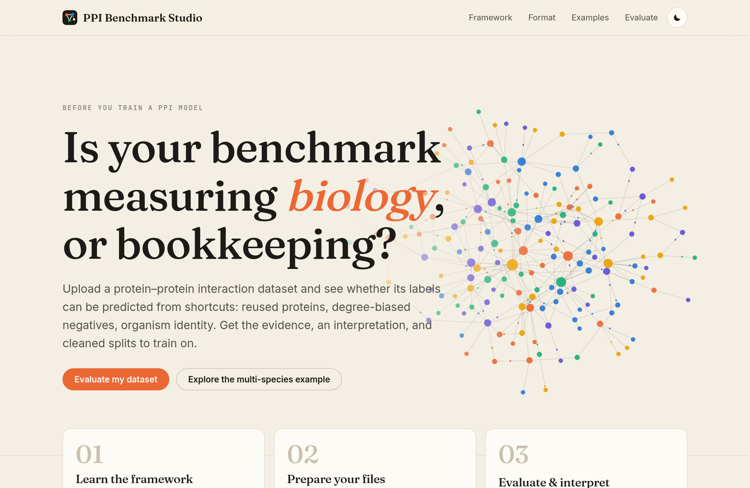
Covers app version 0.1.0 · analysis framework ppi_benchmark_controls 1.0.0
October 2026

Contents

If the page numbers above are missing, right-click the table and choose "Update Field" (Word) or Tools ▸ Update ▸ Update All (LibreOffice).

1. Before you start: what this tool does
PPI Benchmark Studio is a web application that checks a protein–protein interaction (PPI) dataset before anyone trains a machine-learning model on it. You give it a list of proteins and a list of protein pairs. It tells you whether the "right answers" (the labels) in your dataset can be guessed through shortcuts that have nothing to do with biology.
Think of it as a quality inspection for an exam paper. If the answers to a test can be guessed from the length of each question or from which page it is on, a student can score highly without learning anything. A machine-learning model behaves the same way: it will happily learn any shortcut the data allows. The Studio looks for three well-known shortcuts in PPI data:
- Protein reuse: the same proteins appear in both the training data and the test data, so a model can memorise "this protein interacts a lot" instead of learning how two proteins interact.
- Degree-biased negatives: the non-interacting pairs ("negatives") were chosen in a way that makes them look different from the interacting pairs, for example by joining proteins that are rarely studied.
- Organism identity: in data pooled from several species, negatives may join proteins from two different organisms, which a model can spot without understanding anything about interaction.
At the end you get a plain-language verdict, interactive charts with explanations, and cleaned files (pair lists, train/test splits and negative sets) that you can use to build a better model.

1.1 A two-minute biology primer
Proteins are the working molecules of a cell. Many of them do their jobs by physically binding to other proteins. Scientists record these bindings as interactions: each interaction is a pair of proteins, say A and B. Put many interactions together and you get a network, in which each protein is a dot and each interaction is a line (Figure 1).
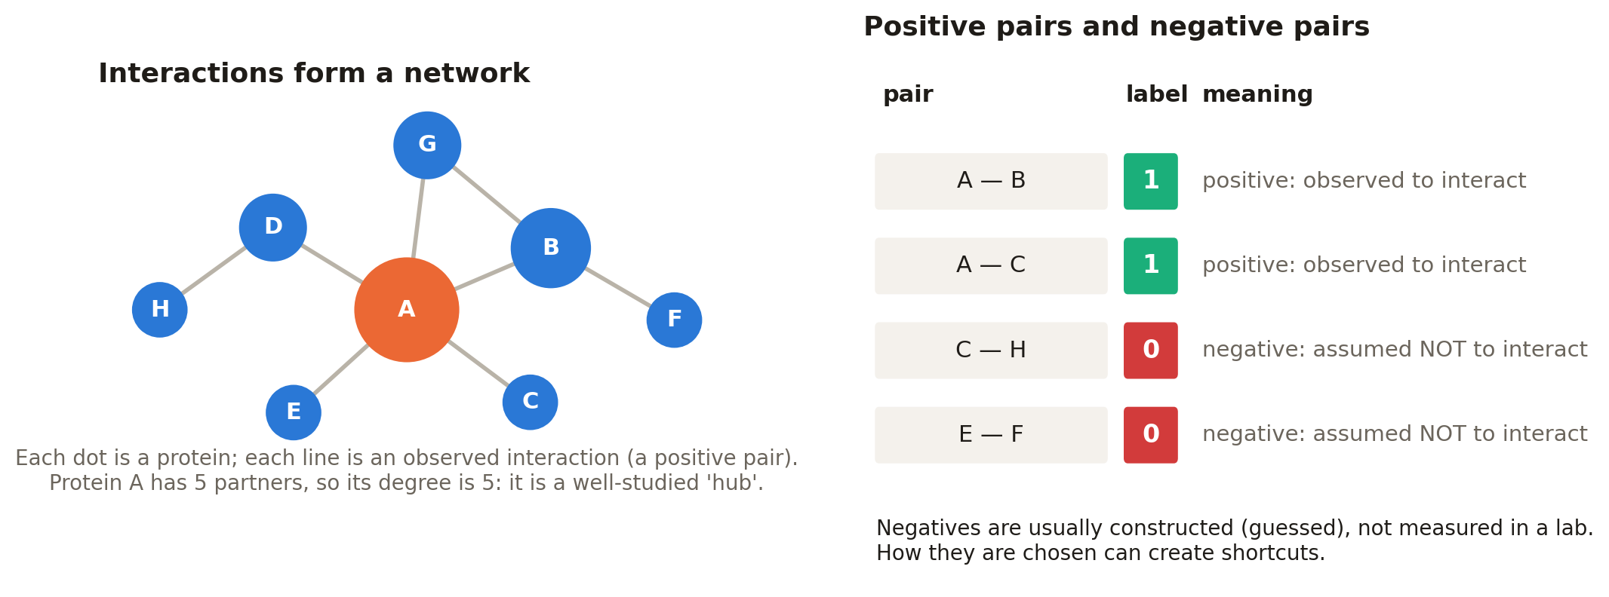
Figure 1. Left: proteins as dots, interactions as lines. A protein's "degree" is the number of partners it has. Right: a pair table, where label 1 means "interacts" and 0 means "assumed not to interact".
A machine-learning model for PPI prediction is trained on positive pairs (known interactions, label 1) and negative pairs (label 0). Laboratories rarely confirm that two proteins do not interact, so negatives are almost always constructed: someone picks pairs that have not been observed to interact and assumes they do not. That choice is where many problems come from (Figure 2).
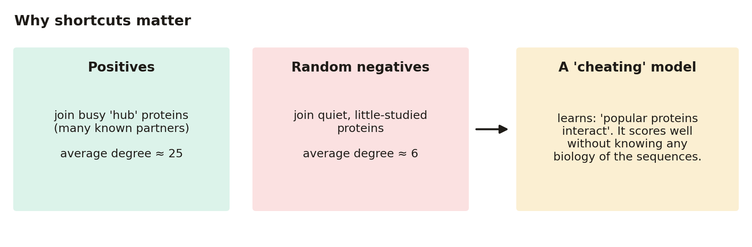
Figure 2. How a degree shortcut arises. If positives join well-studied proteins and negatives join obscure ones, a model can separate them by popularity alone.
IN PLAIN WORDS
The Studio asks one question many different ways: "Is this dataset measuring biology, or bookkeeping?" Bookkeeping means artefacts of how the dataset was assembled, such as which proteins happen to be well studied.

1.2 Words you will see (glossary)
Term | What it means in this app
Protein ID | The name or accession code of a protein, for example P53049 (a UniProt accession). It must be spelled the same way in every file.
Sequence | The protein written as a string of amino-acid letters, for example MSTQKLSEG….
Pair / interaction | Two proteins listed together in the pair file. Order does not matter: A–B is the same as B–A.
Positive (label 1) | A pair observed to interact.
Negative (label 0) | A pair assumed not to interact. The app calls these "putative" because nobody proved they do not interact.
Degree | How many interaction partners a protein has in the positive network. High-degree proteins are "hubs", often the most studied ones.
Canonical pair | A pair after cleaning: written in a fixed order, with duplicates, reversed duplicates and self-pairs removed.
N0, N1, N2, N3, N5… | Names of negative sets. N0 = the negatives you supplied; N1 = random; N2 = degree-matched; N3 = length-matched; N5 = degree + length matched (Section 11).
R0, R1, R2, R3 | Names of test regimes (train/test splits). R0 = random split; R1 = both proteins seen in training; R2 = one unseen; R3 = both unseen (Section 12).
ROC-AUC | A score from 0 to 1 that measures how well a model ranks positives above negatives. 0.5 = guessing; 1.0 = perfect (Section 8.4).
SMD | Standardized mean difference: how far apart two groups' averages are, in units of spread. Above 0.25 is a meaningful imbalance.
Connected component | A group of test pairs linked by shared proteins. Components, not single pairs, are the truly independent pieces of evidence.
Bootstrap / jackknife | Two ways of estimating uncertainty by repeatedly resampling the data. They produce the error bars (confidence intervals).
Leakage | Information from the test data that slips into training, making results look better than they are.
LR, RF, MLP, XGB | Model types: logistic regression, random forest, multi-layer perceptron (a small neural network) and XGBoost.
AAC+CTD | Amino-acid composition plus composition–transition–distribution descriptors: 167 numbers that summarise each protein's sequence. It is the built-in protein representation.
Embedding | An optional pre-computed numerical summary of each protein (for example from the ESM-2 protein language model) that you can upload.

1.3 Opening the app
The Studio runs in your web browser. Someone (perhaps you) has to start the server first. On the computer where the project is installed, open a terminal in the project folder and run:
docker compose up --build
When the terminal shows Uvicorn running on http://0.0.0.0:8000 and "GET /api/health HTTP/1.1" 200 OK, open http://localhost:8000 in Chrome, Firefox, Edge or Safari. To stop the server, press Ctrl+C in that terminal or run docker compose down.
WATCH OUT
If you see bind: address already in use for port 8000, another copy of the Studio (or another program) is already using that port. Stop the other copy, or change the first number in ports: ["127.0.0.1:8000:8000"] in docker-compose.yml (for example to 8001) and open http://localhost:8001 instead.
Running docker compose down -v also deletes the stored datasets and results. Leave out -v unless you want that.

If you use a shared server set up by your institution, simply open the web address you were given. Nothing needs to be installed on your own computer.

1.4 The whole journey at a glance
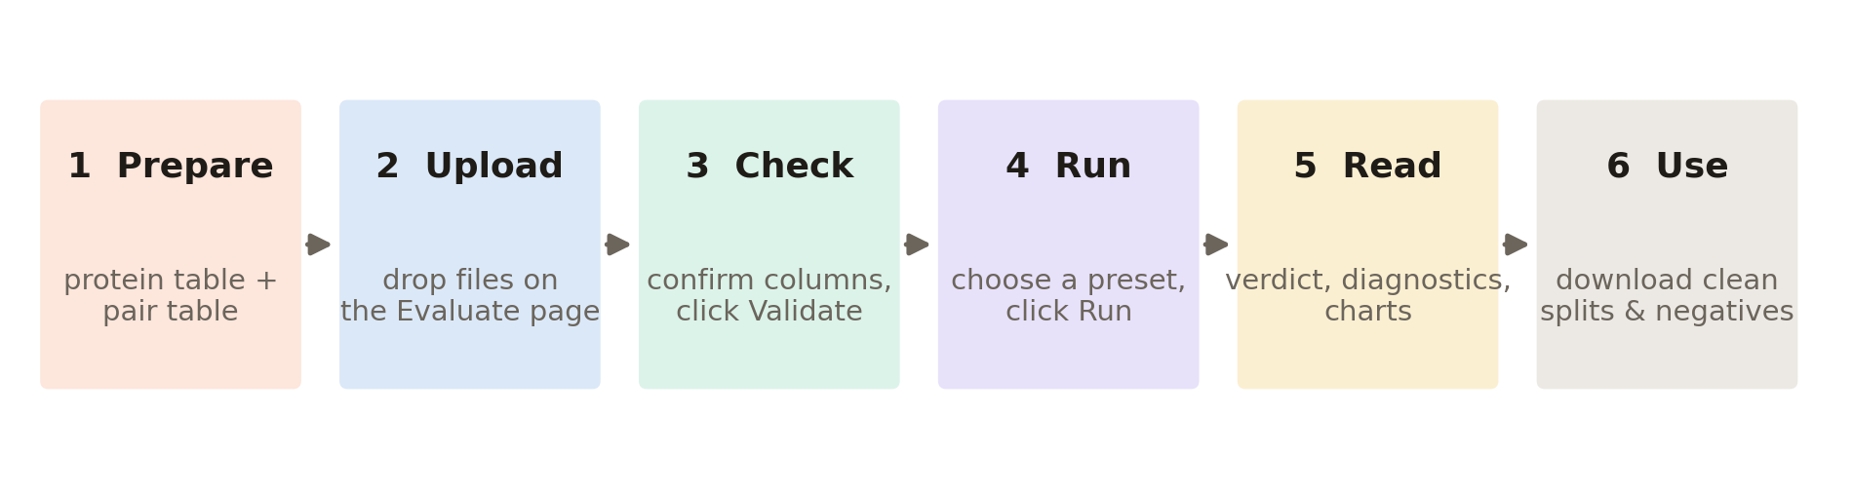
Figure 3. The six steps of a typical session. Steps 2–4 happen on the Evaluate page; steps 5–6 on the results page.
- Prepare two text files: a protein table and a pair table (Section 4).
- Upload them on the Evaluate page (Section 6).
- Check that the app read the columns correctly, then validate (Section 6.2).
- Run the analysis with a preset (Section 6.3) and wait for it to finish (Section 7).
- Read the verdict and the result chapters (Sections 8–14).
- Use the cleaned files and the ready-made methods paragraph (Section 14).
TIP
No data yet? Every step can be practised with built-in example data. On the Evaluate page click Use synthetic data (fast) or Use the multi-species benchmark (realistic).

2. A tour of the interface

2.1 The navigation bar
The bar across the top of every page stays visible while you scroll. It is your way around the app.
Figure 4. The navigation bar: logo and name on the left, page links and the light/dark switch on the right.
Element | What it looks like | What it does
Logo + "PPI Benchmark Studio" | Dark square with four coloured dots joined by lines (a tiny interaction network) | Click it from anywhere to return to the home page.
Framework | Text link | Opens the explanation of the scientific method behind the checks (Section 3.2). Hidden on narrow phone screens.
Format | Text link | Opens the input-format guide with templates and a format checker (Section 4).
Examples | Text link | Opens three worked examples with full, pre-computed results (Section 5).
Evaluate | Text link | Opens the upload-and-run page where you analyse your own data (Section 6).
Theme button | Round button with a moon (in light mode) or a sun (in dark mode) | Switches between light and dark colours. Your choice is remembered in this browser.

The link for the page you are on is highlighted with a light grey pill. At the very top-left there is also an invisible "Skip to content" link that appears when you press the Tab key, for keyboard and screen-reader users.
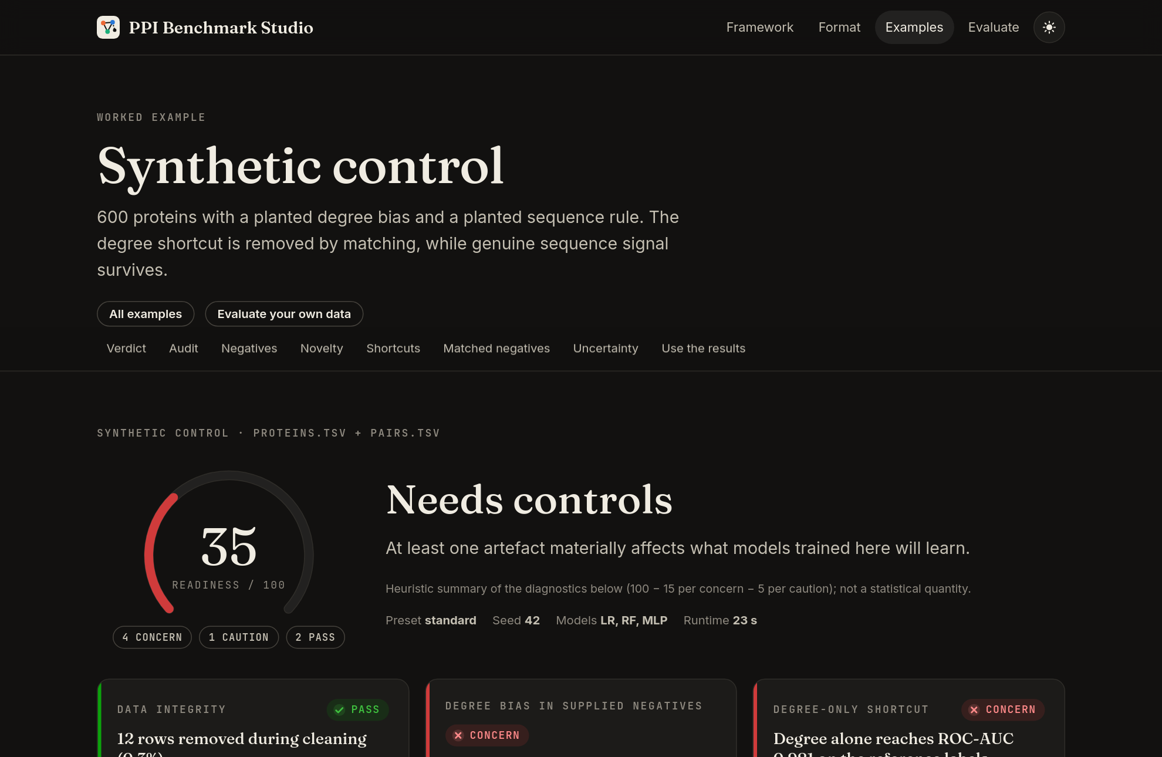
Figure 5. Dark mode, switched on with the sun/moon button. All pages and charts adapt.

2.2 The footer
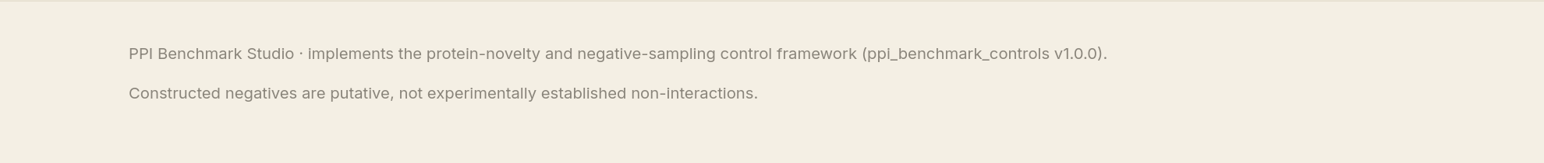
Figure 6. The footer at the bottom of every page.
The footer names the scientific framework the app implements (ppi_benchmark_controls v1.0.0) and repeats the most important caveat: constructed negatives are putative, not experimentally established non-interactions. In other words, a "negative" in this app means "not observed", never "proven not to interact".

3. The home page and the Framework page

3.1 Home page
Figure 7. The home page. The animated network in the background is decorative.
Item | Explanation
Headline "Is your benchmark measuring biology, or bookkeeping?" | Sums up the purpose of the tool.
Evaluate my dataset (orange button) | Takes you straight to the Evaluate page to upload your files.
Explore the multi-species example (outlined button) | Opens the full results of the multi-species example: the quickest way to see what a finished report looks like.
Moving network picture | An animated illustration of an interaction network. Decorative only.

Below the headline are three numbered cards, the recommended learning path:
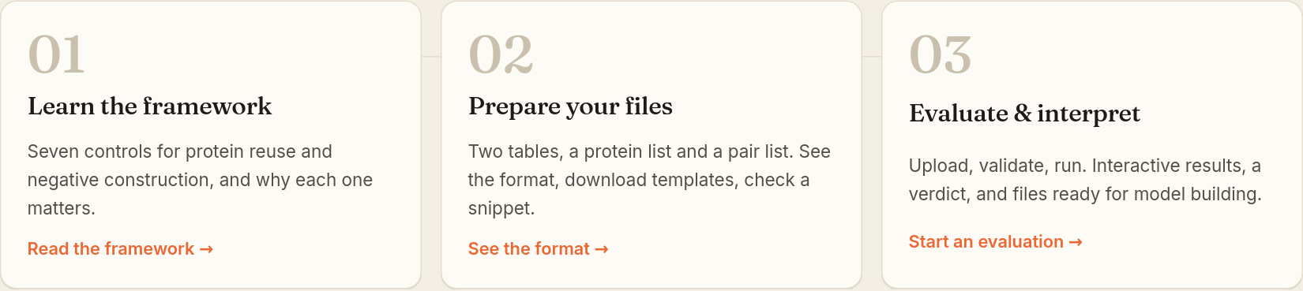
Figure 8. The three path cards. Each card is a link: click anywhere on it.
- 01 Learn the framework → Read the framework: opens the Framework page.
- 02 Prepare your files → See the format: opens the Format guide.
- 03 Evaluate & interpret → Start an evaluation: opens the Evaluate page.
Further down, the section "Seven controls, one verdict" lists the steps the analysis performs (Figure 9). The last section shows three short findings from the built-in examples. They show why it is worth checking your own data: one benchmark looks excellent but teaches nothing, pooling species adds a shortcut, and every dataset behaves differently.
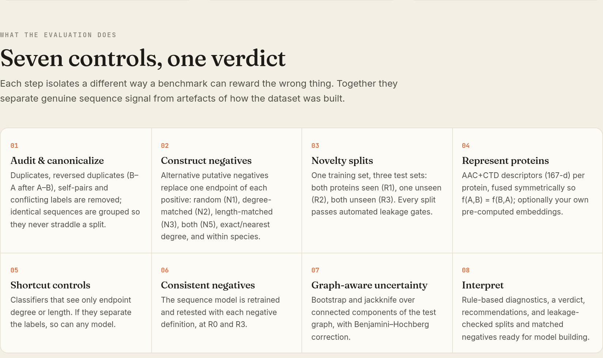
Figure 9. The eight numbered analysis steps (seven controls plus interpretation). The same panel appears on the Framework page.
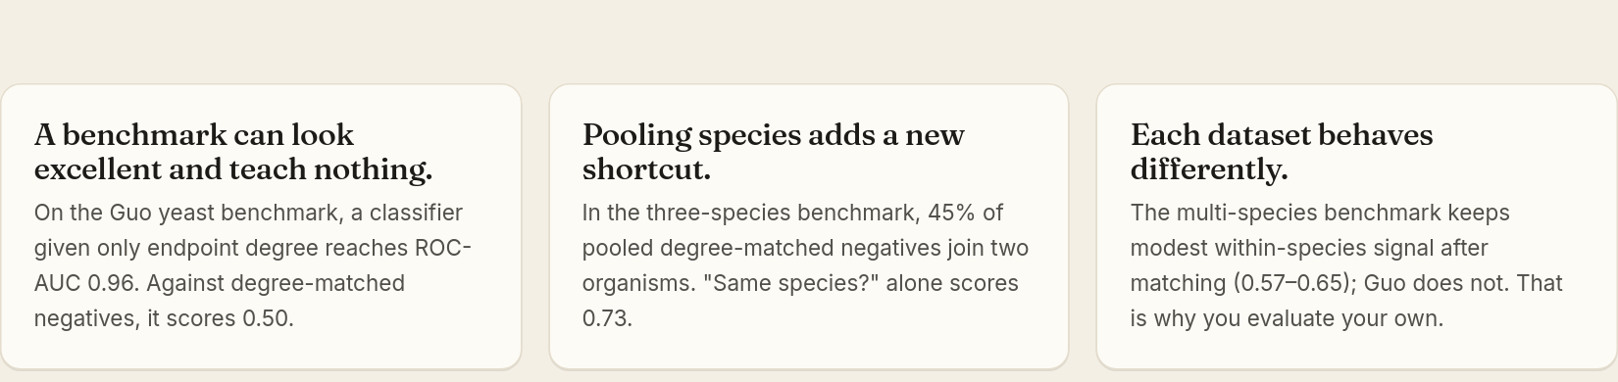
Figure 10. Three headline findings from the worked examples.

3.2 Framework page
This page explains the scientific idea in about one screen of text. Read it once; it makes every result easier to understand.
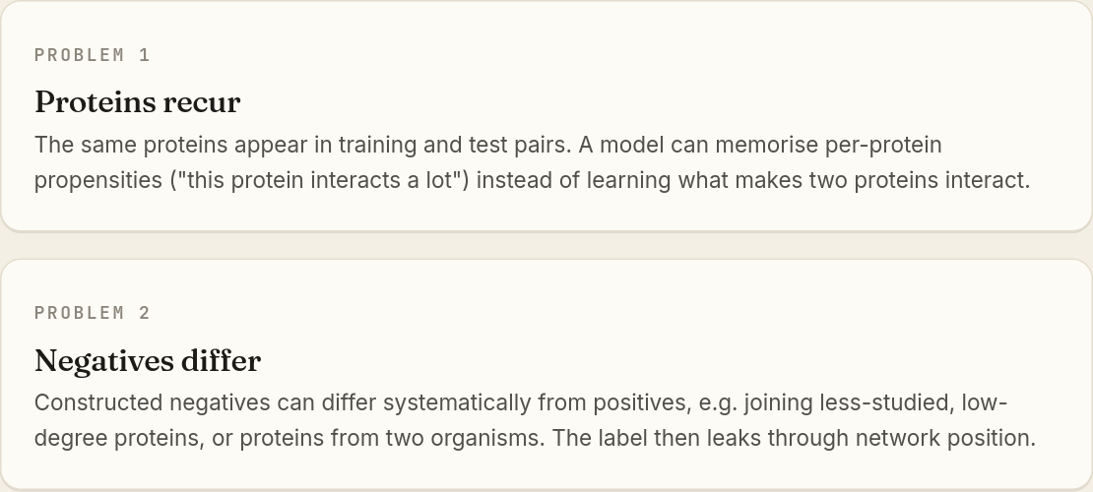
Figure 11. "Two problems that look like one": protein reuse and biased negatives.
Problem 1: Proteins recur. The same proteins appear in training and test pairs, so a model can memorise per-protein habits. Problem 2: Negatives differ. Constructed negatives can differ systematically from positives (for example, joining less-studied proteins, or proteins from two organisms). The important point is that fixing one problem does not fix the other. A split where the proteins don't overlap can still have biased negatives, and balanced negatives can still let proteins recur. So the Studio controls both.
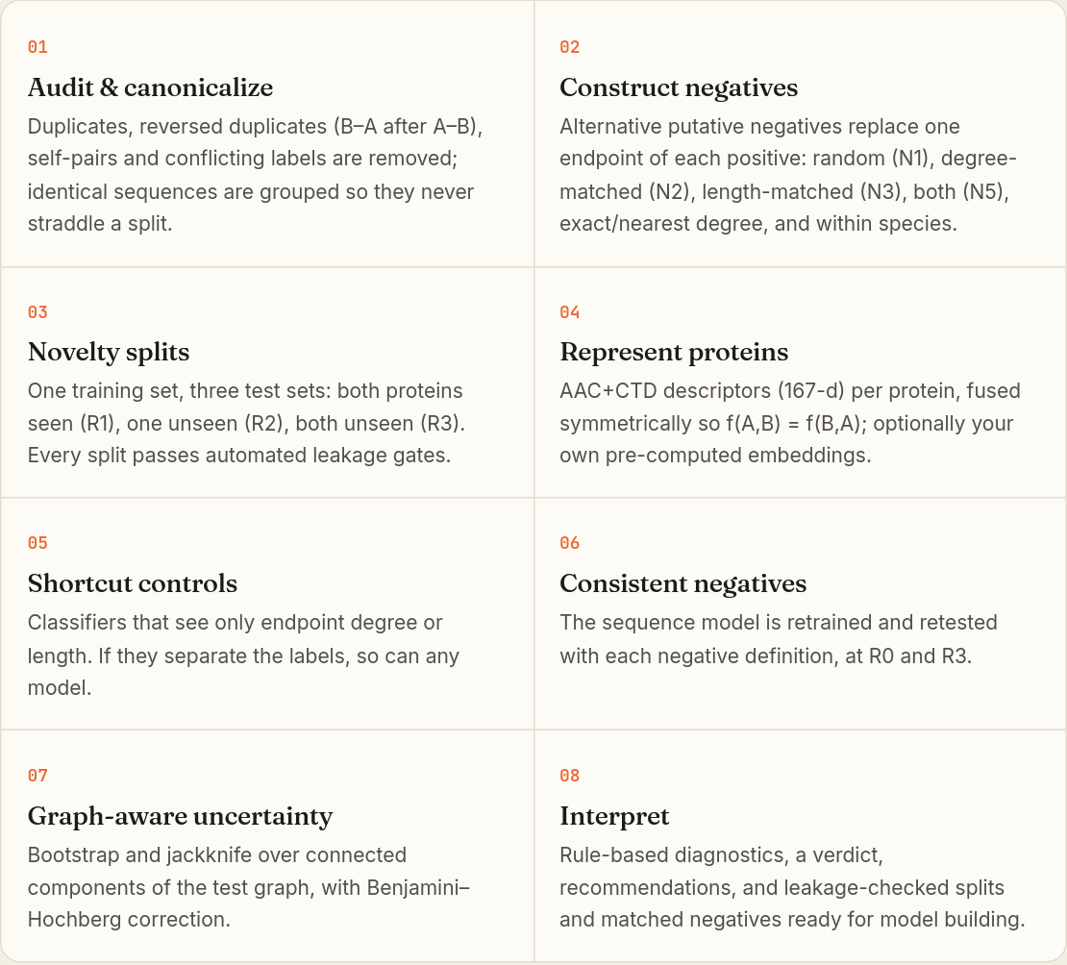
Figure 12. The analysis steps in order. Each step is explained in detail in Sections 9–14 of this tutorial.
Step | In everyday language
01 Audit & canonicalize | Tidy the data: remove duplicate, reversed and self-pairs and contradictory labels; group identical sequences.
02 Construct negatives | Build several alternative sets of negatives that are fairer comparisons for the positives.
03 Novelty splits | Make test sets where the proteins are increasingly unfamiliar to the model, and check for leakage.
04 Represent proteins | Turn each sequence into numbers (167 AAC+CTD descriptors), or use your own embeddings.
05 Shortcut controls | Train "cheating" models that see only degree or only length. If they score well, the labels are leaky.
06 Consistent negatives | Retrain the real sequence model with each fair negative set and see what signal survives.
07 Graph-aware uncertainty | Put honest error bars on the scores, respecting that test pairs share proteins.
08 Interpret | Turn all of the above into a verdict, recommendations and ready-to-use files.

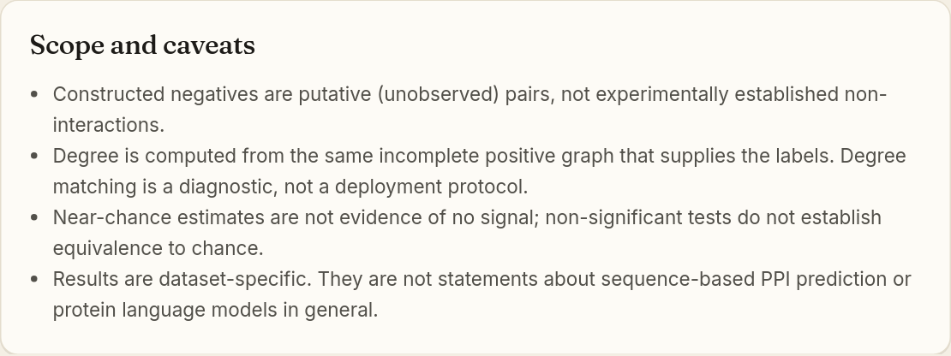
Figure 13. Scope and caveats: read these before quoting results.
WATCH OUT
A score close to chance does not prove there is no biological signal; it means the data cannot show one. Results describe your dataset only, not sequence-based PPI prediction in general.

Two buttons end the page: Evaluate a dataset (to the Evaluate page) and See worked examples (to the Examples page).

4. Preparing your files (the Format page)
The Format page explains exactly what the app can read. Only two files are required.
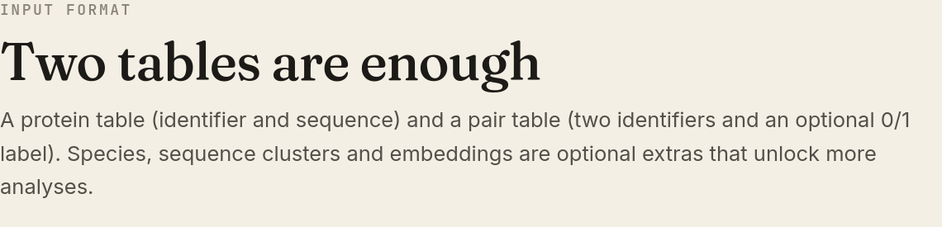
Figure 14. Top of the Format page. The grey line below the title shows this server's limits (file size and number of pairs).

4.1 The protein file (required)
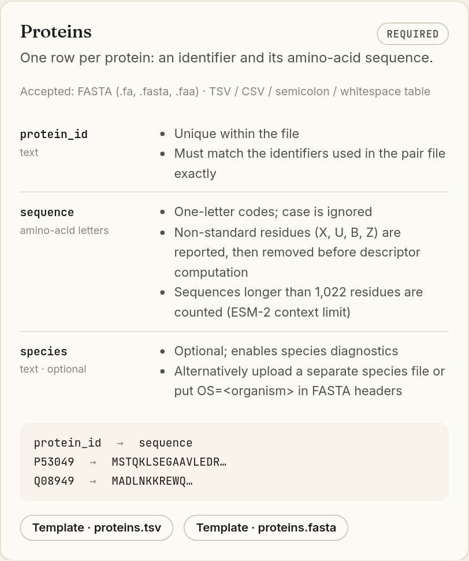
Figure 15. The Proteins card: the required columns, their rules, an annotated example and template downloads.
Column | Required? | Rules
protein_id | Yes | Unique in the file; must match the IDs in the pair file exactly (same capitals, no extra spaces).
sequence | Yes | One-letter amino-acid codes; upper/lower case does not matter. Unusual letters (X, U, B, Z) are reported and removed before the descriptors are calculated. Sequences longer than 1,022 letters are counted (the ESM-2 limit) but kept.
species | No | Turns on the species checks. You can instead upload a separate species file or put OS=<organism> in FASTA headers.

Accepted formats: FASTA (.fa, .fasta, .faa) or a table separated by tabs (TSV), commas (CSV), semicolons or spaces.

4.2 The pair file (required)
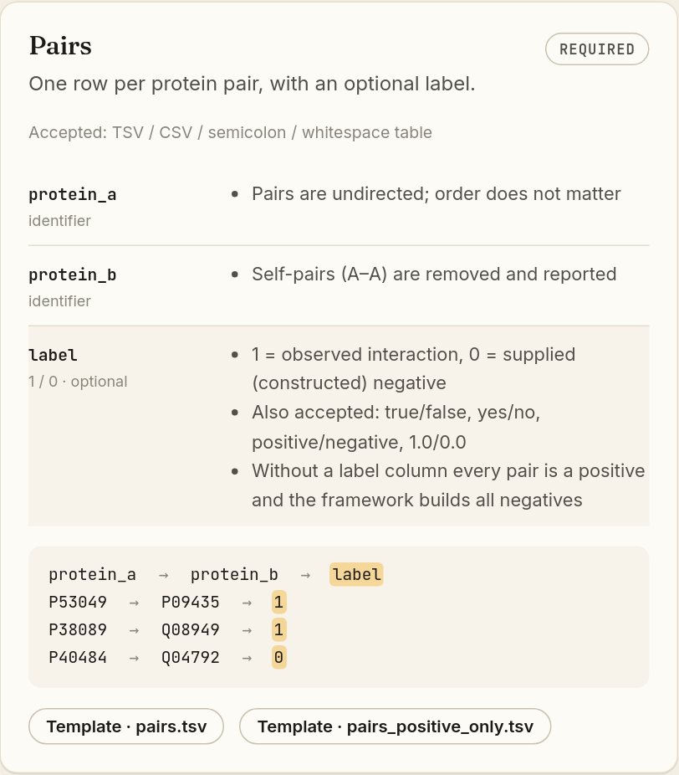
Figure 16. The Pairs card. Moving the mouse over a rule (here "label") highlights the matching column in the yellow example below it.
Column | Required? | Rules
protein_a | Yes | First protein of the pair. Order does not matter.
protein_b | Yes | Second protein. A pair of a protein with itself (A–A) is removed and reported.
label | No | 1 = observed interaction; 0 = a negative you constructed. Also accepted: true/false, yes/no, positive/negative, 1.0/0.0. With no label column, every pair is treated as a positive and the app builds all negatives itself.

Template buttons (for example "Template · pairs.tsv") download a small, correctly formatted example file. Open it in a spreadsheet program or a text editor and replace the contents with your own data. pairs_positive_only.tsv is the template for data without negatives.
TIP
If you build the file in Excel, use File ▸ Save As ▸ Text (Tab delimited) or CSV. Do not upload .xlsx files.

4.3 "Check a snippet": test your file before uploading
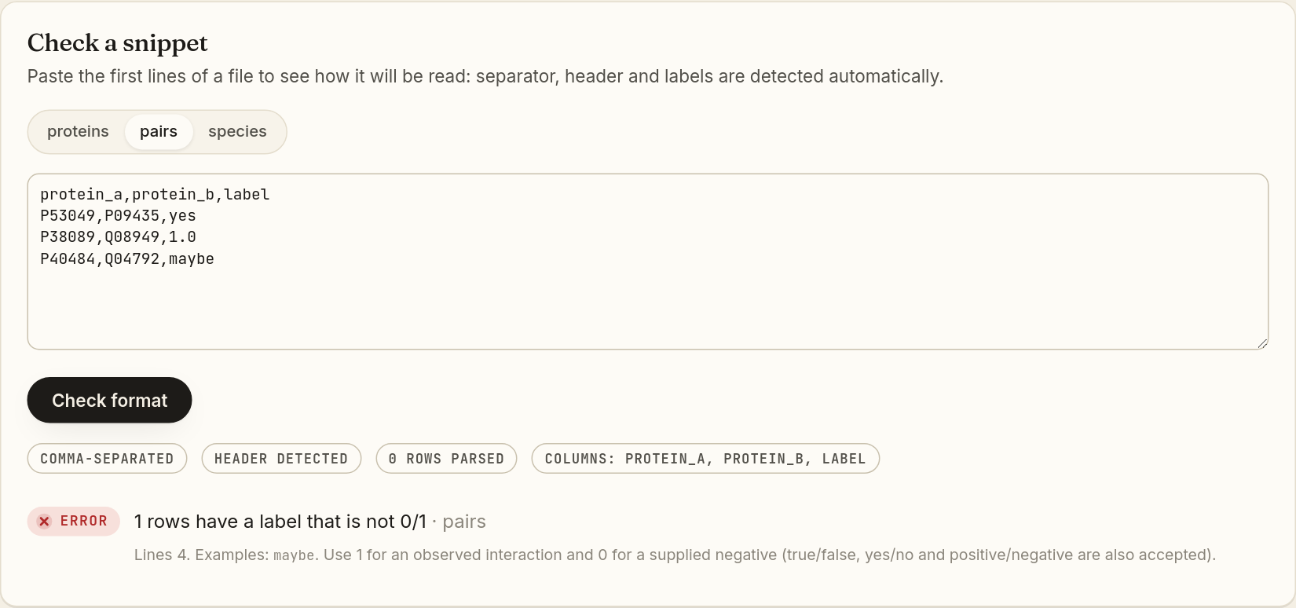
Figure 17. The snippet checker. The default text has a deliberate mistake ("maybe" is not a valid label), so the result shows an Error badge.
- Choose the file type with the three-way switch: proteins, pairs or species. The selected option is shown as a white pill.
- Paste the first few lines of your file into the large text box (copy them from a text editor or spreadsheet).
- Click Check format. While working, the button reads "Checking…".
- Read the grey pills that appear: how the file is separated (comma-, tab-…), whether a header row was detected, how many rows were parsed and which columns were found.
- Read any issues below. Each issue has a coloured badge, a message, the file it refers to, the line numbers and a hint on how to fix it.
In the example above, line 4 has the label "maybe". The hint explains that only 1/0 (or true/false, yes/no, positive/negative) are allowed.

4.4 Optional files
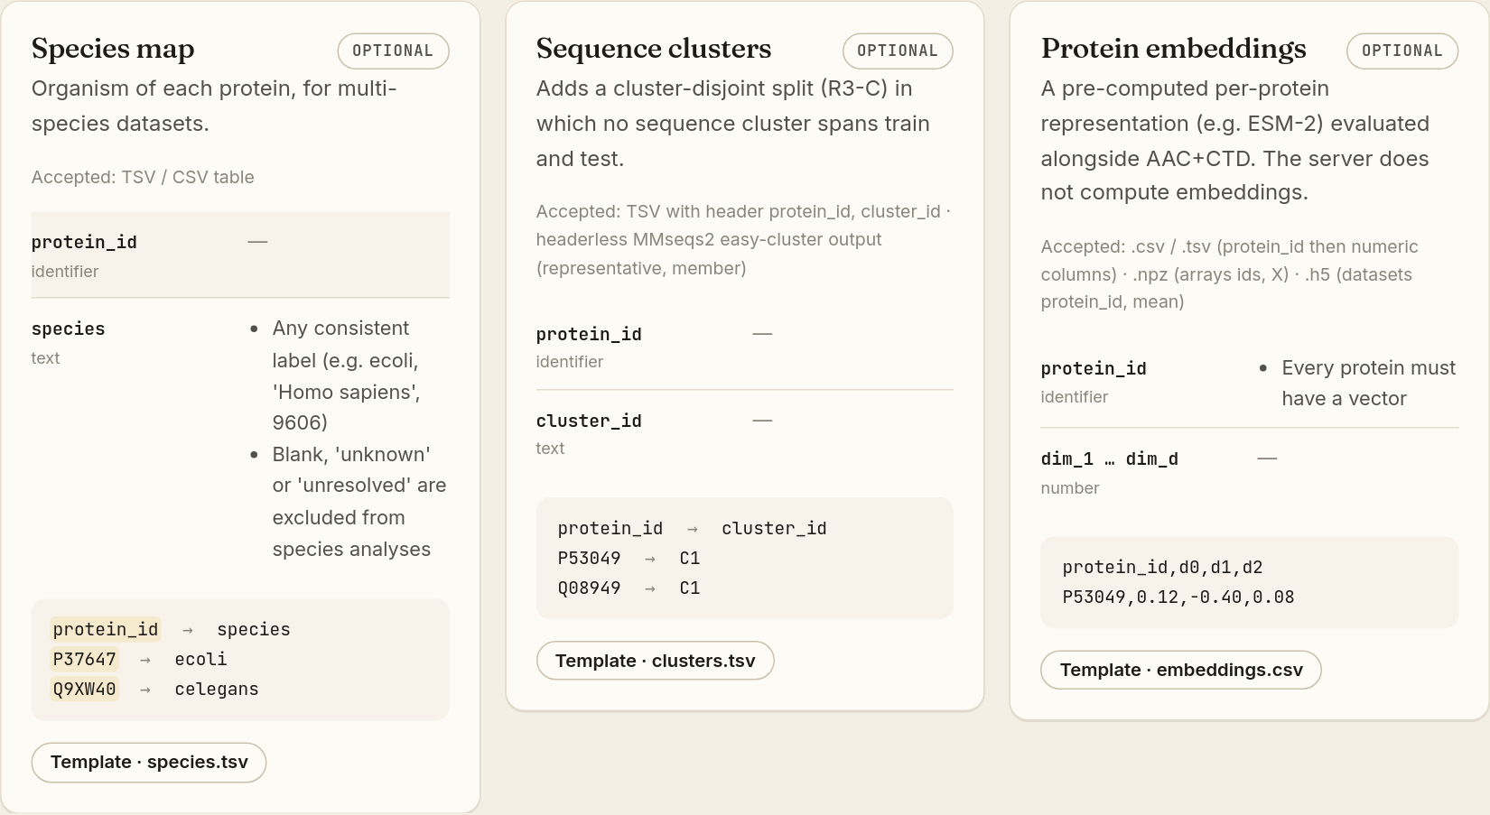
Figure 18. Optional files: species map, sequence clusters and embeddings.
File | Why you might add it | What it unlocks
Species map (protein_id, species) | Your data contain proteins from more than one organism. | Chapter 7 "Species": cross-species checks, the "same species?" shortcut and within-species results. Labels such as blank, "unknown" or "unresolved" are left out of species analyses.
Sequence clusters (protein_id, cluster_id) | You have grouped similar sequences (for example with MMseqs2) and want a stricter test. | An extra split, R3-C, where no cluster of similar sequences is shared between training and test.
Embeddings (protein_id + numbers) | You have pre-computed vectors such as ESM-2 embeddings. The server does not compute them for you. | Every analysis is repeated with your embeddings next to AAC+CTD, and a switch appears on the charts to change between them.

At the bottom, the card "Without supplied negatives" reminds you that a pair file with no 0 labels is fine: the app then uses random unobserved pairs (N1) as the reference. The Upload my files button jumps to the Evaluate page.

5. Worked examples: learn by looking
The Examples page holds three complete analyses of known datasets. Open them before analysing your own data, so you know what "bad", "mixed" and "good" patterns look like.
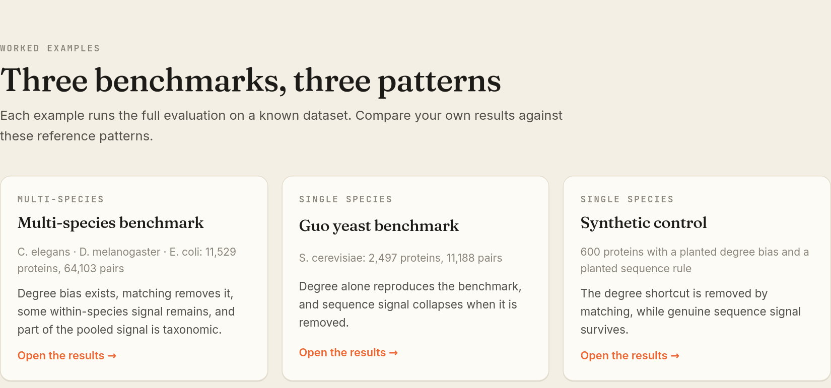
Figure 19. The Examples page. Each card shows whether the data are single- or multi-species, the dataset size, a one-line story and an "Open the results" link.
Example | Data | What it teaches | Verdict (score)
Multi-species benchmark | Worm, fly and E. coli: 11,529 proteins, 64,103 pairs | Degree bias exists and matching removes it. Some within-species signal remains, and part of the pooled signal comes from species identity. | Needs controls (20)
Guo yeast benchmark | Baker's yeast: 2,497 proteins, 11,188 pairs | Degree alone reproduces the benchmark; sequence signal collapses once the shortcut is removed. | Shortcut-dominated (25)
Synthetic control | 600 made-up proteins with a planted degree bias and a planted sequence rule | Matching removes the shortcut while the genuine (planted) sequence signal survives. | Needs controls (35)

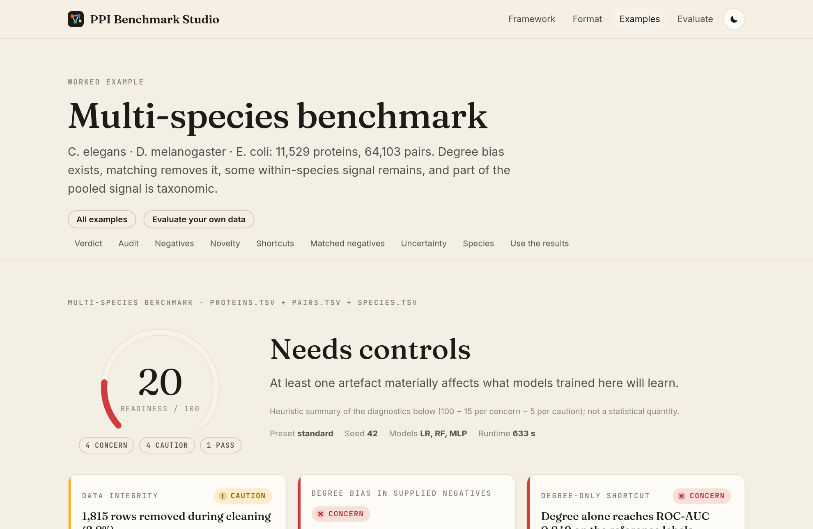
Figure 20. Top of an example's results page. "All examples" goes back to the list; "Evaluate your own data" goes to the upload page. Below them is the chapter bar.
Example results pages look and work exactly like the results of your own analysis, so everything in Sections 8–14 applies to them. The only difference is that there is no "Full bundle (.zip)" button. The individual files can still be downloaded.

6. Running an evaluation, step by step
Click Evaluate in the navigation bar. The page title is "Upload, check, run". The grey text under it says how long your files are kept (on this server: 30 days) and reminds you that anyone with a result link can open it. Keep links private if your data are unpublished.

The step indicator
Under the introduction is a row of three pills: 1 Files, 2 Check, 3 Configure & run. The current step has a dark outline. Finished steps show a green tick ✓ and future steps are grey. You can always go back with the Back buttons.

6.1 Step 1: Files
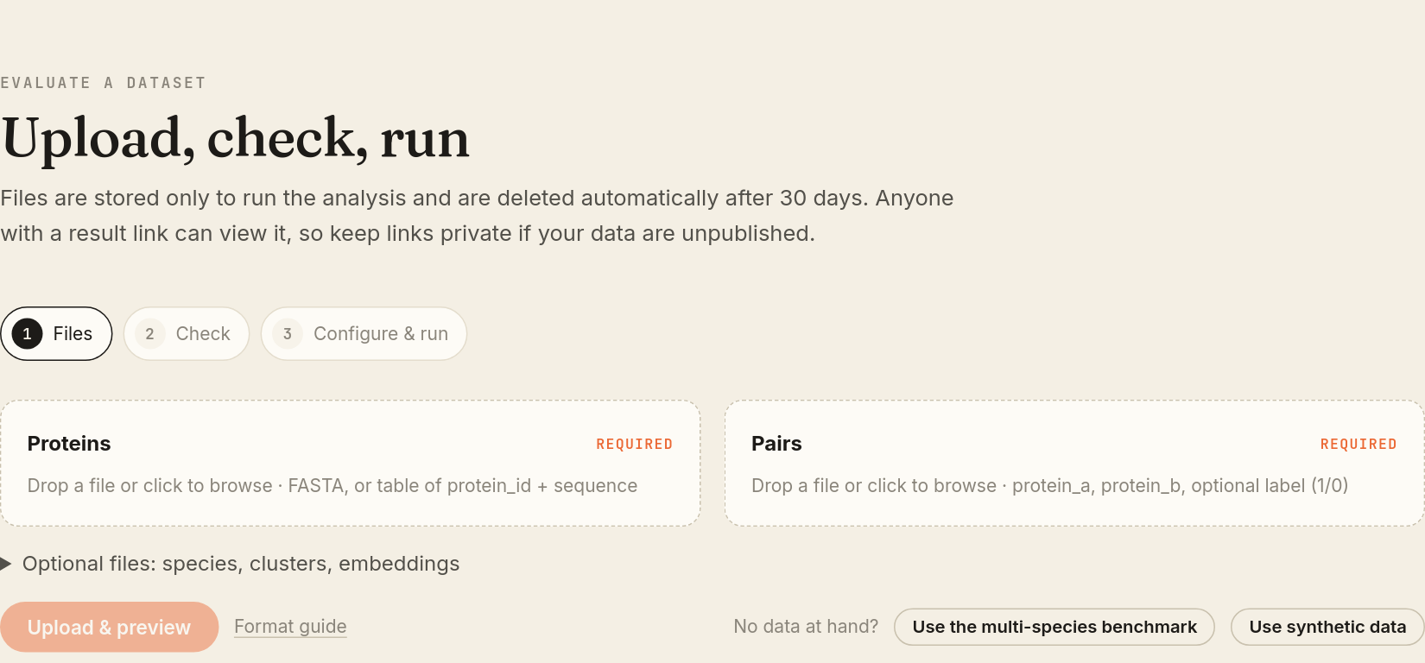
Figure 21. Step 1 before any file is chosen. The orange "Upload & preview" button stays faded until both required files are chosen.
Element | How to use it
Proteins box (marked "required") | Drag your protein file onto the box, or click the box to open a file browser. Accepts .tsv, .csv, .txt, .tab, .fa, .fasta, .faa.
Pairs box (marked "required") | Same, for the pair file. Accepts .tsv, .csv, .txt, .tab.
▸ Optional files: species, clusters, embeddings | Click this line to unfold three more boxes: Species map, Sequence clusters and Embeddings (Section 4.4).
Remove (inside a filled box) | Clears that file so you can choose another.
Upload & preview (orange) | Sends the files to the server and moves to Step 2. While working it reads "Uploading".
Format guide (grey link) | Opens the Format page.
No data at hand? → Use the multi-species benchmark | Loads the example dataset (three species) and jumps to Step 2.
No data at hand? → Use synthetic data | Loads the small synthetic dataset and jumps to Step 2. Ideal for a first try because it runs in seconds.

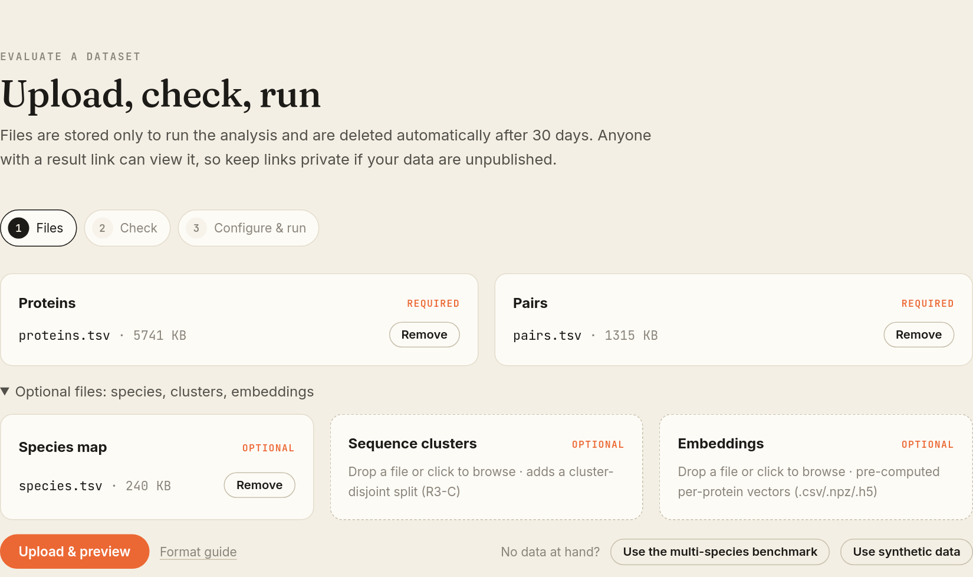
Figure 22. Step 1 with files chosen. Each box shows the file name and size and a Remove button. The optional section is unfolded.
TIP
When you drag a file over a box, the box is highlighted to show it will accept the drop.

6.2 Step 2: Check (column mapping and validation)
The app guesses which column is which. In this step you confirm that it guessed correctly.
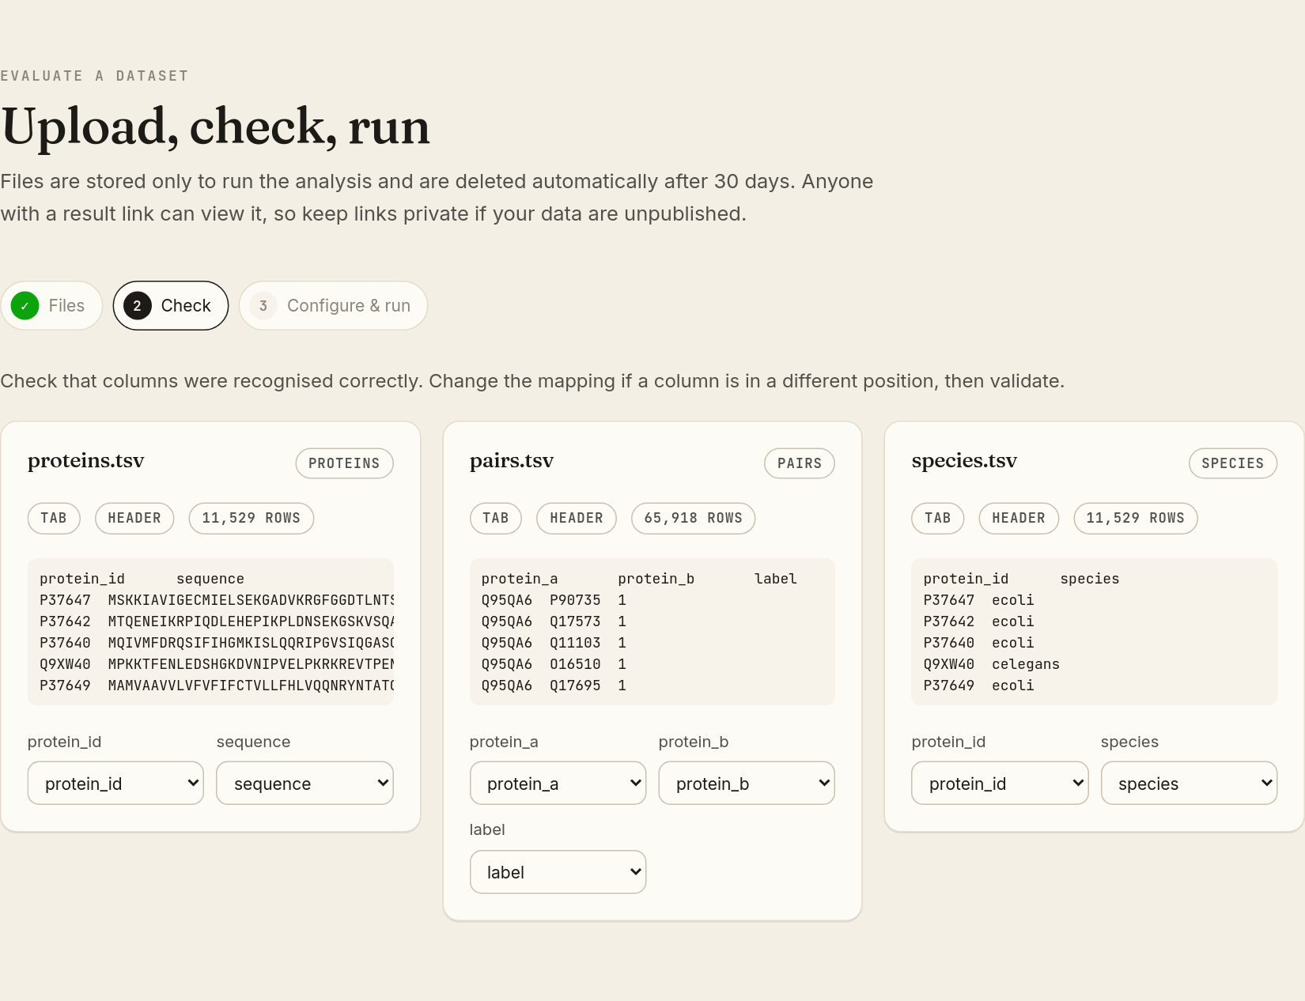
Figure 23. Step 2. One card per uploaded file with a preview of the first rows and drop-down menus for the column roles.
Element | Meaning
Card title (for example "proteins.tsv") and grey tag | The file name and the role it was uploaded as (proteins, pairs or species).
Pill "TAB" / "COMMA" / "FASTA" | How the app thinks columns are separated.
Pill "HEADER" / "NO HEADER" | Whether the first line was recognised as column names.
Pill "11,529 ROWS" | How many data rows were found.
Grey preview box | The first five lines, exactly as read. Check that IDs and sequences appear in the right columns.
Drop-down menus (protein_id, sequence, species, protein_a, protein_b, label) | Each one says which column of your file fills that role. Change it if the guess is wrong. Optional roles have a "(none)" choice.
Validate | Runs a full check of all files with the chosen mapping. While working it reads "Validating".
Back | Returns to Step 1.

After you click Validate, a report card appears:
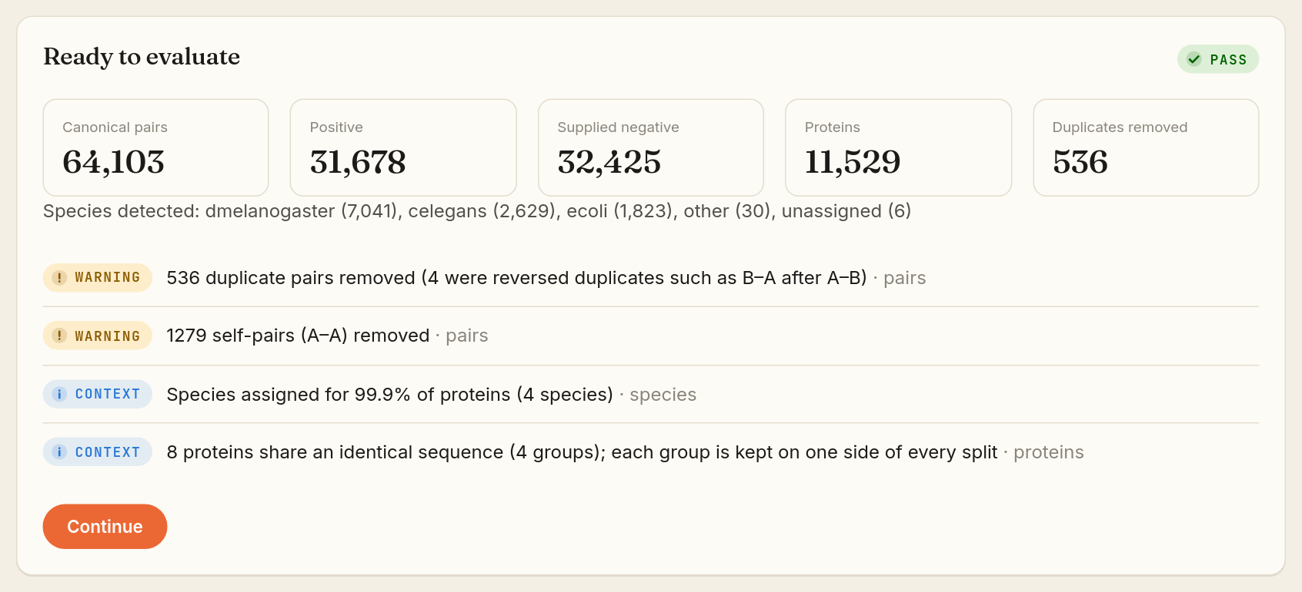
Figure 24. The validation report for the multi-species example. Here it is "Ready to evaluate" with a green Pass badge.
Part of the report | What to look at
Heading + badge | "Ready to evaluate" with ✓ Pass, or "Please fix these issues" with ✕ Error.
Canonical pairs | Pairs left after cleaning (duplicates and self-pairs removed).
Positive / Supplied negative | How many pairs have label 1 / label 0.
Proteins | How many proteins were read.
Duplicates removed | Repeated pairs that were dropped (A–B listed twice, or B–A after A–B).
Species detected | Shown only when species information exists, with the number of proteins per species.
Issue list | Each line has a badge: ✕ Error (must be fixed before you can continue), ! Warning (worth knowing, but the run can go ahead) or i Context (information).
Continue (orange) | Appears only when there are no errors. Moves to Step 3.

IN PLAIN WORDS
Warnings such as "536 duplicate pairs removed" are normal for real-world data. The app removes these automatically and tells you so that you know your raw file has them.

Changing any drop-down after validating hides the report. Click Validate again to refresh it.

6.3 Step 3: Configure & run
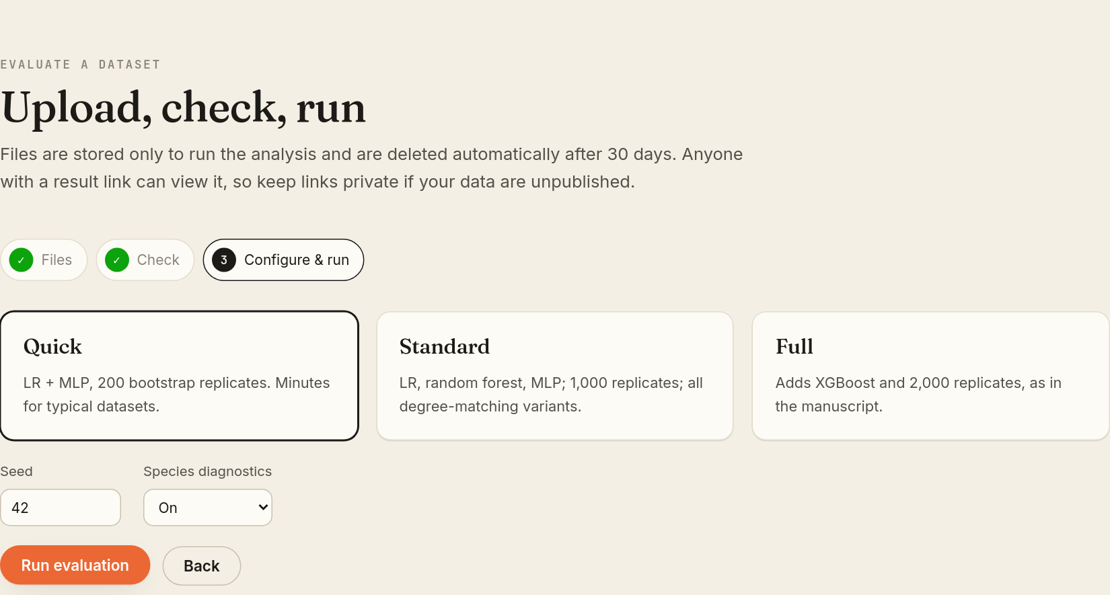
Figure 25. Step 3: choose a preset, a seed and (for multi-species data) whether to run species diagnostics.
Presets are three clickable cards. The selected card has a dark border.
Preset | Models used | Bootstrap replicates | When to choose it
Quick (default) | Logistic regression + MLP | 200 | First look, teaching, or large files. Minutes for typical datasets (the synthetic example takes about 15 seconds).
Standard | Logistic regression, random forest, MLP | 1,000 | The normal choice for a report. Also builds the extra degree-matching variants (N2-exact, N2-nearest). The multi-species example took about 10 minutes.
Full | Adds XGBoost | 2,000 | Reproduces the published manuscript settings. Slowest.

Setting | Meaning
Seed (number box, default 42) | The starting number for every random choice the app makes (splits, negatives, models). The same data with the same seed and preset always gives the same results. Change it only if you want to see how much results move with different random choices.
Species diagnostics (On/Off) | Shown only when two or more species were detected. "On" adds the Species chapter; "Off" skips it.
Run evaluation (orange) | Starts the analysis and opens the progress page. While starting it reads "Starting".
Back | Returns to Step 2.

7. While it runs: the progress page
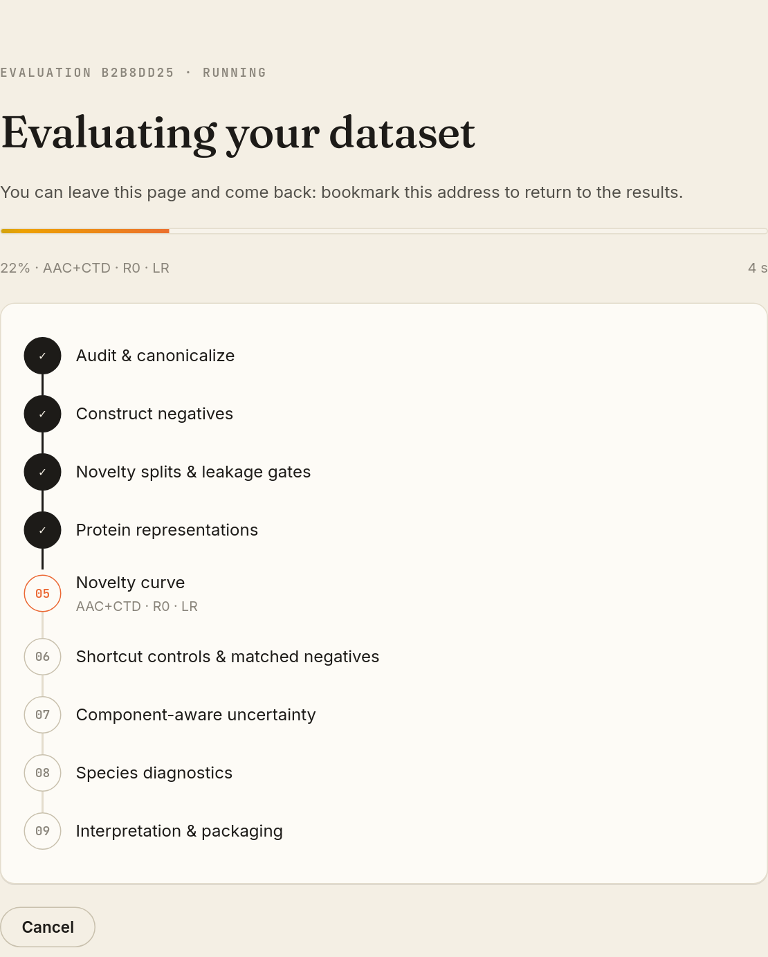
Figure 26. The progress page. Finished stages have a dark ✓ circle, the running stage an orange outlined number with a live status line under it, and future stages grey numbers.
Element | Meaning
Eyebrow "EVALUATION B2B8DD25 · RUNNING" | The first 8 characters of your job ID and its status (queued, running).
"Waiting for a free worker" + queue position | Shown instead when the server is busy with other jobs. The page updates by itself.
Orange progress bar + "22% · AAC+CTD · R0 · LR" | Percent complete and what is being computed right now.
Seconds counter (right) | Time elapsed since the job started.
Stage list 01–09 | Audit & canonicalize → Construct negatives → Novelty splits & leakage gates → Protein representations → Novelty curve → Shortcut controls & matched negatives → Component-aware uncertainty → Species diagnostics → Interpretation & packaging.
Cancel | Stops the job. The page then shows "Evaluation cancelled".

TIP
You do not have to keep the page open. Bookmark the address (it looks like /jobs/b2b8dd25…). Opening it later shows the progress, or the results once they are ready.

If something goes wrong the page shows "The evaluation could not finish" with a ✕ Concern badge, the error message and, where possible, a list of issues to fix. "Back to upload" returns to the Evaluate page. If the link is older than the retention period, you will see "Evaluation not found". Results are deleted automatically after that time.

8. Reading the results: the controls you will use everywhere
When the job finishes, the progress page turns into the results page. It is one long page divided into chapters. Before going chapter by chapter, here are the controls that appear throughout.

8.1 The chapter bar
Figure 27. The chapter bar. It sticks under the navigation bar as you scroll; click a name to jump to that chapter.
Chapters: Verdict · Audit · Negatives · Novelty · Shortcuts · Matched negatives · Uncertainty · Species (only for multi-species data) · Use the results.

8.2 Chart cards, "View data", legends and tooltips
Every chart sits on a card with a title, a one-line explanation under it, an optional legend (coloured dots or lines with labels) and a View data button.
Control | What it does
View data / Chart | Switches the chart to a plain table of the exact numbers behind it, and back. Use this to copy values or if colours are hard to tell apart.
Legend | Says what each colour or line style stands for. Colours are fixed per item across the whole report: N2 is always the same green, for example.
Hover tooltip | Hover over (or Tab to) a point, bar or cell to see a small box with the exact values.
Segmented switch (for example LR · RF · MLP) | A row of pills in the top-right corner of some charts. Click one to change what the chart shows; the selected pill is white.
"chance" line | A dashed vertical or horizontal line at ROC-AUC 0.5: the score of random guessing.

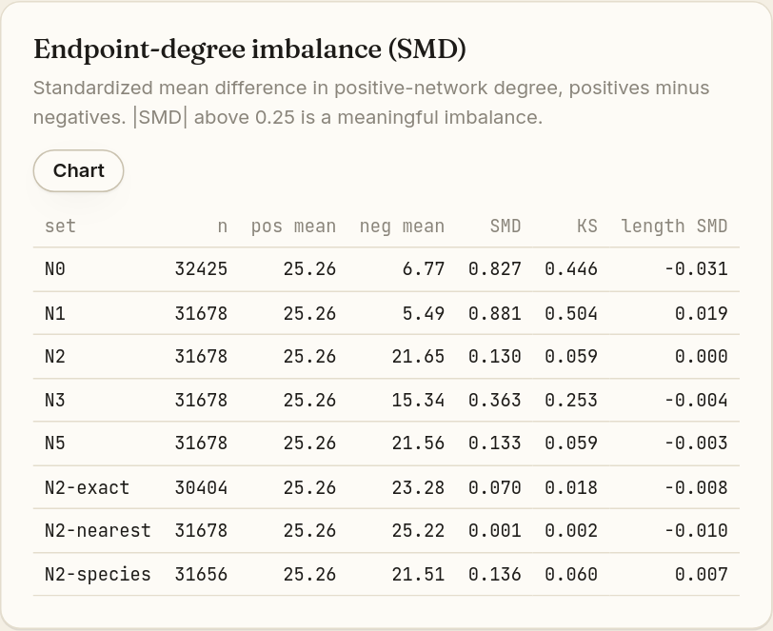
Figure 28. The same chart after clicking "View data": the button now reads "Chart".
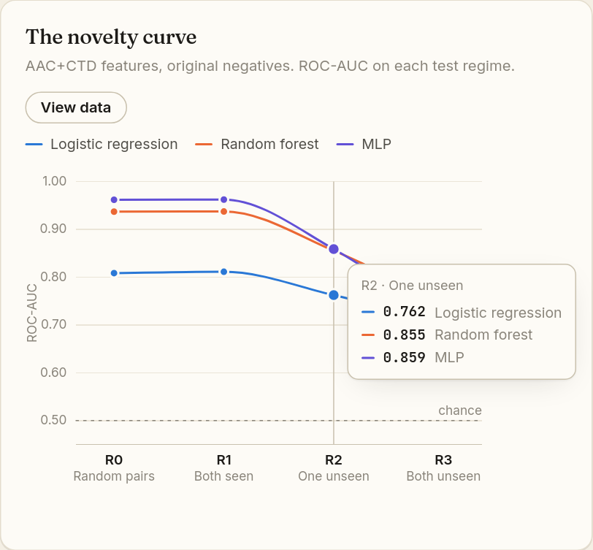
Figure 29. Hovering on the novelty curve shows a tooltip with every model's value at that point.
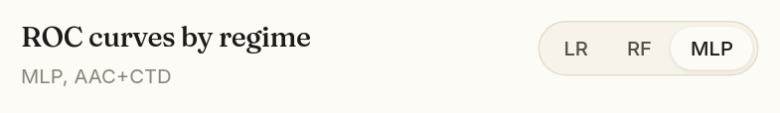
Figure 30. A segmented switch (LR · RF · MLP) in a chart's header.

8.3 Status badges
Every finding carries a badge with an icon and a word, so you never have to rely on colour alone.
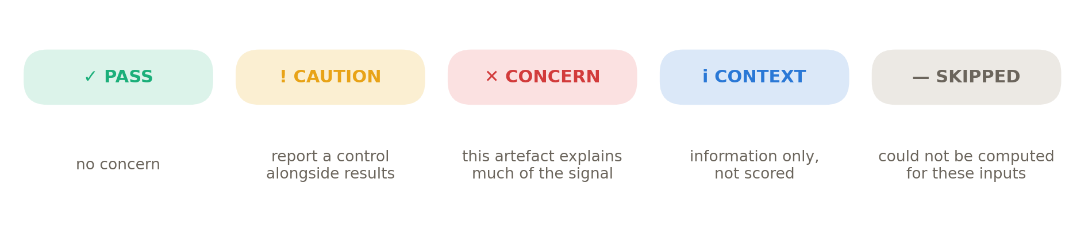
Figure 31. The five status badges and what they mean.

8.4 How to read ROC-AUC
Most charts report ROC-AUC. Imagine taking one random positive pair and one random negative pair and asking the model which is more likely to interact. ROC-AUC is the proportion of such comparisons the model gets right.
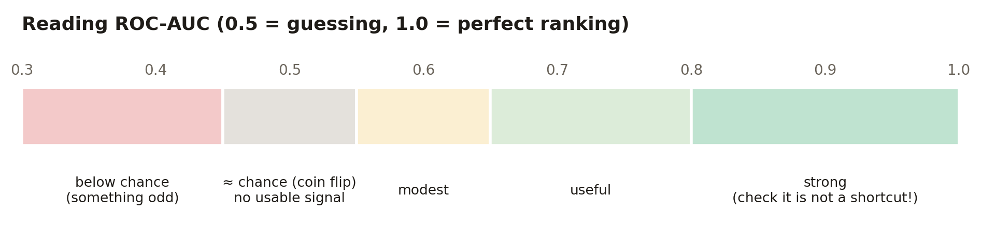
Figure 32. A rough guide to ROC-AUC values. Context matters: a high score from a shortcut is not good news.
WATCH OUT
In this app a high score is not automatically good. If a model that sees only degree scores 0.85, the dataset is leaky. The question is always: high compared with what, and does it survive when shortcuts are removed?

8.5 Diagnostic cards and inline call-outs
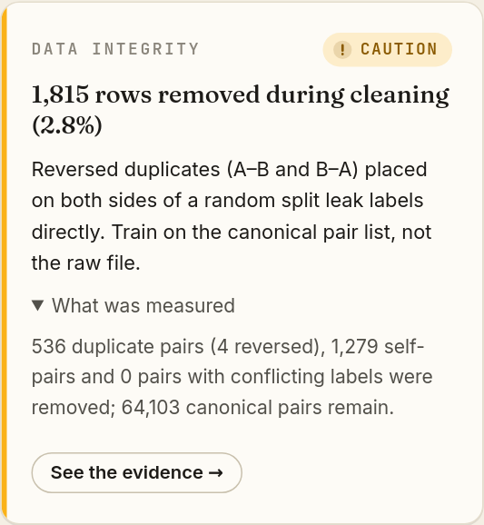
Figure 33. A diagnostic card with "What was measured" unfolded.
Part of the card | Meaning
Small grey title (for example DATA INTEGRITY) | Which check this is.
Badge (top right) | Pass, Caution, Concern, Context or Skipped.
Coloured left edge | Repeats the status colour: green, amber, red or blue.
Bold headline | The finding in one sentence, with the key number.
Normal text | What it means for building a machine-learning model.
▸ What was measured | Click to unfold the exact measurement and, where relevant, a caveat in smaller text.
See the evidence → | Scrolls to the chapter with the charts behind this finding.

Inside chapters, the same findings appear as call-outs next to the relevant chart: a box with a coloured left bar, the badge, the headline in bold and the implication.
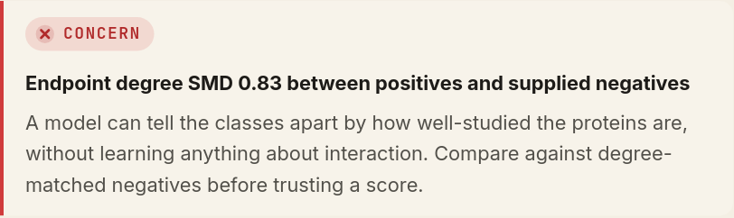
Figure 34. An inline call-out in the Negatives chapter.

9. Chapter 0: the verdict (overview)
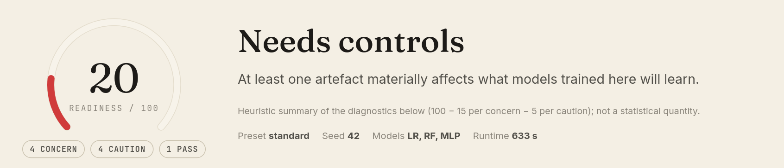
Figure 35. The verdict panel for the multi-species example.
Element | Meaning
Readiness ring with a number /100 | A summary score. The coloured arc fills in proportion to the score: green at 80 and above, amber 50–79, red below 50.
Pills "4 concern · 4 caution · 1 pass" | How many diagnostics had each status. Context items are not counted.
Large verdict word | One of four verdicts (Figure 36).
Sentence under the verdict | What the verdict means.
Small grey note | Reminds you the score is a rule of thumb, not a statistic.
Preset · Seed · Models · Runtime | Exactly how this analysis was run, so it can be repeated.
Eyebrow line above (for example "MULTI-SPECIES BENCHMARK · PROTEINS.TSV + PAIRS.TSV + SPECIES.TSV") | Which files were analysed.

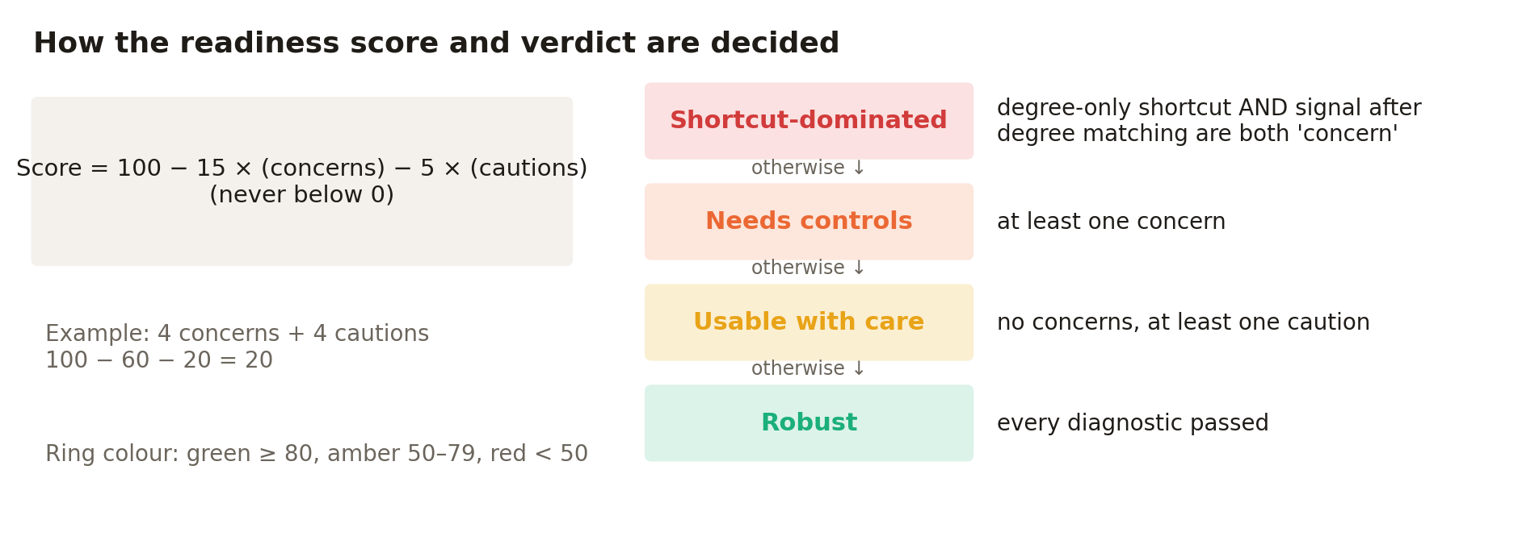
Figure 36. How the score and verdict are calculated from the diagnostics.
Under the verdict is a grid of diagnostic cards, one per check (Figure 37). The full list, with the thresholds that decide each status, is in Section 15.
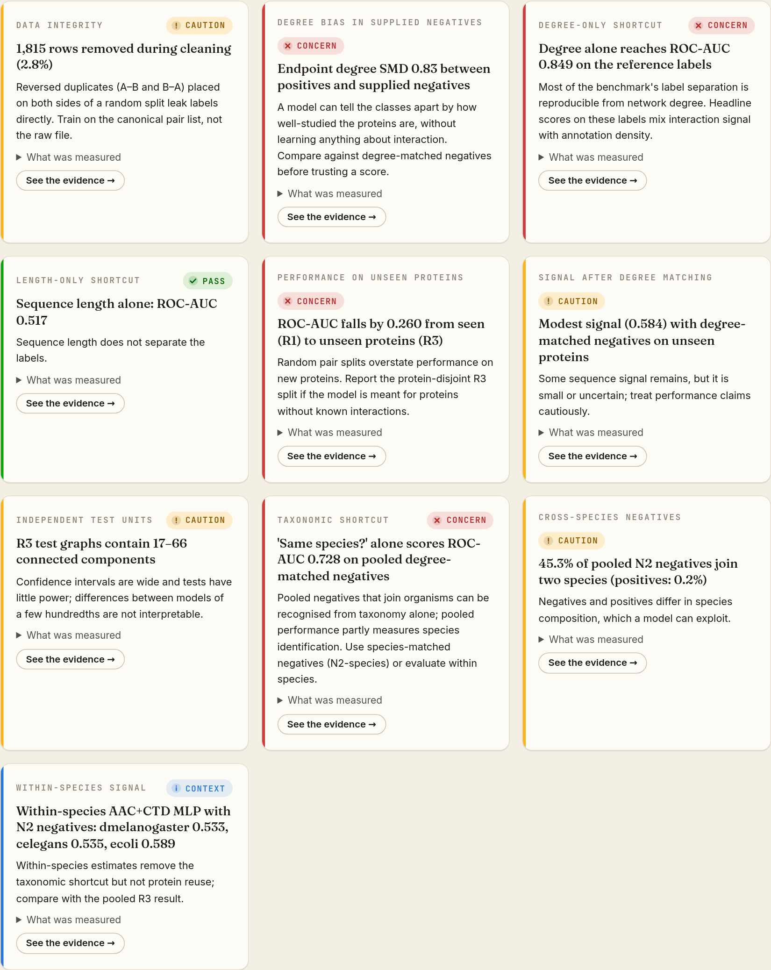
Figure 37. All diagnostic cards for the multi-species example.
IN PLAIN WORDS
Start by reading only the red Concern cards. Each one names a shortcut that explains much of the dataset's apparent performance. Click "See the evidence →" to see the chart behind it.

10. Chapter 1: Audit, "What is actually in the file"
The audit counts what is in your data after cleaning. Pairs are undirected, so A–B and B–A are the same observation; the app writes every pair in a fixed order and removes repeats, self-pairs and pairs with contradictory labels (listed as both 1 and 0).
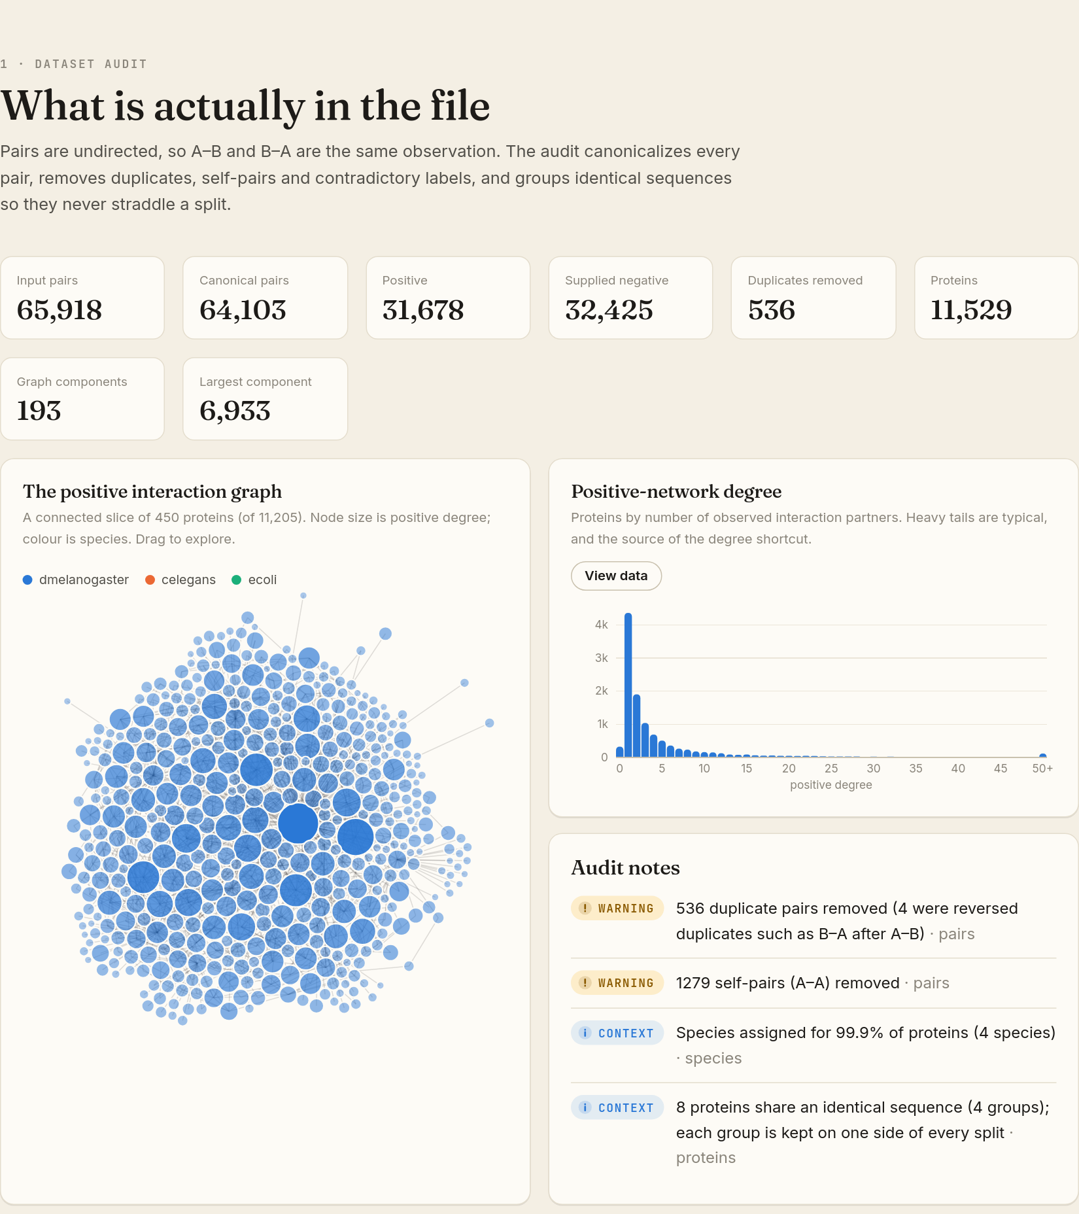
Figure 38. The Audit chapter: number tiles, the interaction-graph picture, the degree histogram and audit notes.
Tile | Meaning | Multi-species example
Input pairs | Rows in your pair file. | 65,918
Canonical pairs | Unique pairs after cleaning. | 64,103
Positive | Pairs with label 1. | 31,678
Supplied negative | Pairs with label 0 (0 if you supplied none). | 32,425
Duplicates removed | Repeated pairs dropped. | 536
Proteins | Proteins in the protein file. | 11,529
Graph components | Separate islands in the network of positive pairs. | 193
Largest component | Proteins in the biggest island. | 6,933

The positive interaction graph
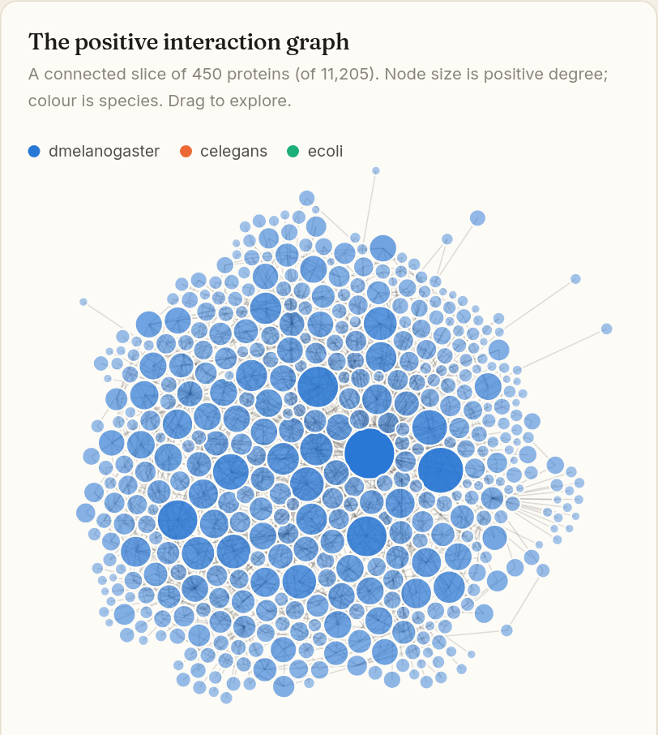
Figure 39. A connected slice of up to 450 proteins. Bigger circles = more partners (higher degree). With species data, colour shows the organism.
This is a picture of part of your positive network. Drag nodes with the mouse to rearrange it. Large circles are hubs. If a handful of huge hubs dominate, degree shortcuts are likely.

Positive-network degree (histogram)
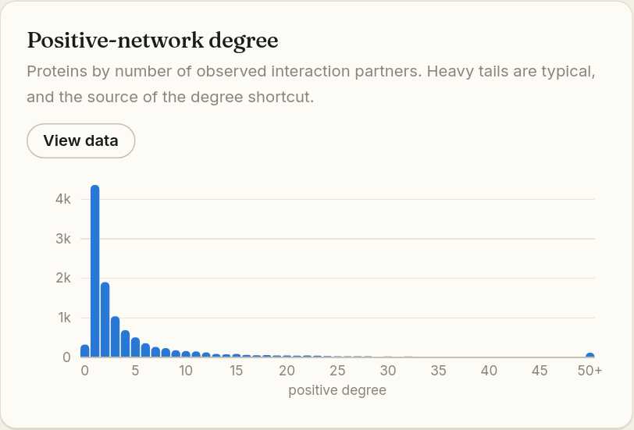
Figure 40. How many proteins have 0, 1, 2… partners. The last bar ("50+") collects all proteins with 50 or more.
Each bar is a degree value (horizontal axis) and its height is the number of proteins with that many partners. Real networks almost always show this "long tail": many proteins with one or two partners and a few hubs with dozens. That tail is where the degree shortcut comes from.

Audit notes
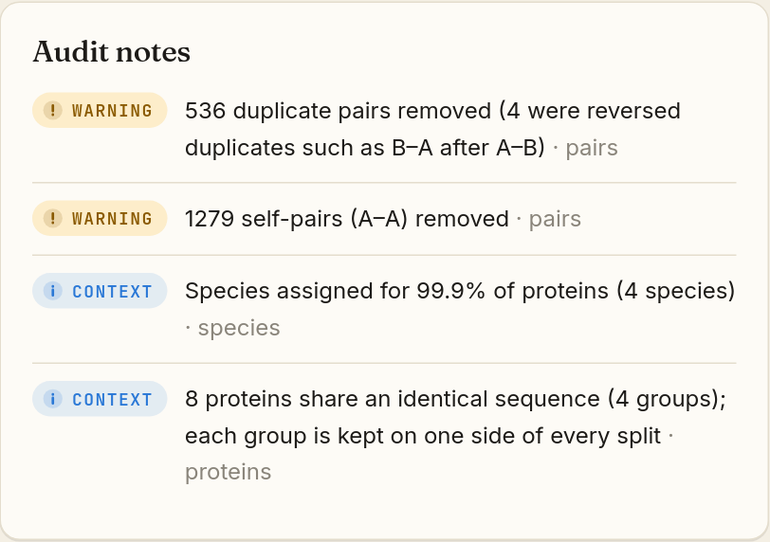
Figure 41. Audit notes: the same issue list as in the validation step.

11. Chapter 2: Negatives, "Do negatives look like positives?"
This chapter compares your negatives with alternative, fairer negative sets that the app builds. Each alternative keeps one protein of a positive pair and swaps the other for a protein matched on a property.
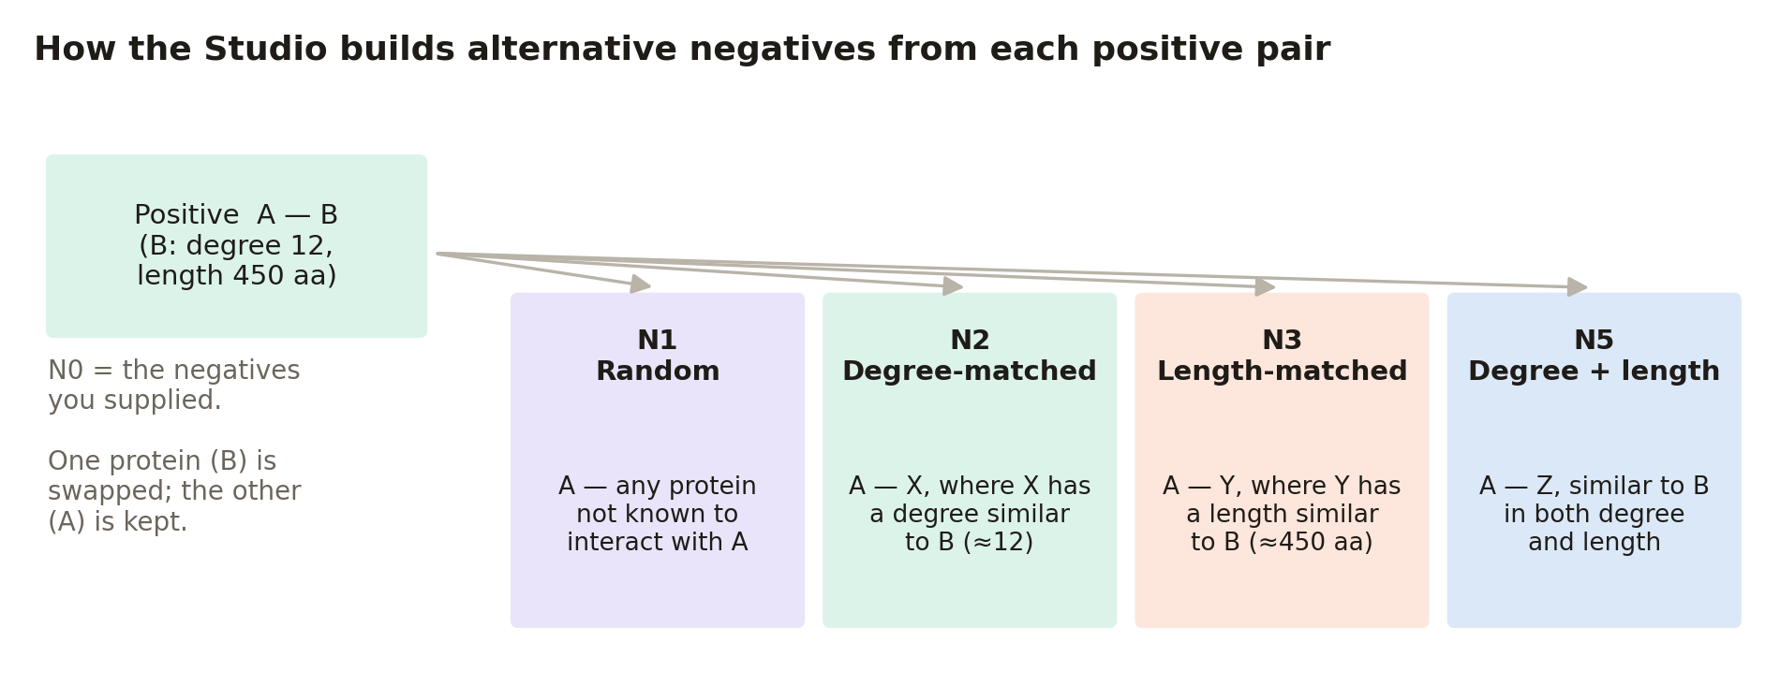
Figure 42. How the alternative negative sets are built from each positive pair.
Set | Name in the app | How it is built
N0 | Original | The negatives you supplied (label 0). Absent if you supplied none.
N1 | Random | Pairs chosen at random from all pairs not observed to interact.
N2 | Degree-matched | Swap one protein for one from the same degree band (decile).
N3 | Length-matched | Swap for a protein with a similar sequence length.
N5 | Degree + length | Swap for a protein similar in both.
N2-exact / N2-nearest | Exact / Nearest degree | Stricter degree matching (Standard and Full presets only).
N2-species | Degree, within species | Like N2, but the substitute must come from the same organism (multi-species data only).

If no valid substitute exists for a positive, no negative is made for it. The matching rule is never relaxed.

Endpoint-degree imbalance (SMD)
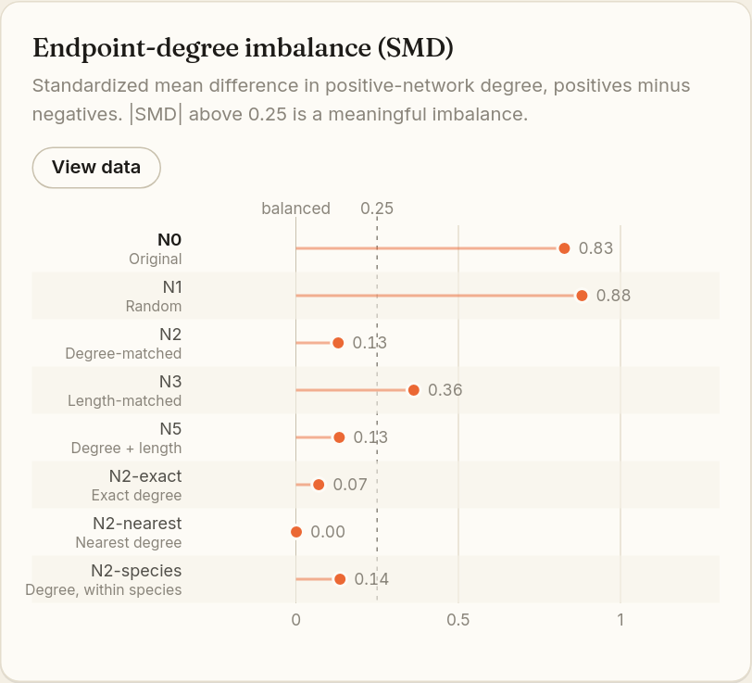
Figure 43. One row per negative set. The dot's position is the SMD; the dashed line at 0.25 marks a meaningful imbalance.
How to read it: the closer a dot is to 0 ("balanced"), the more the negatives resemble the positives in how well connected their proteins are. In the multi-species example the supplied negatives (N0, 0.83) and random negatives (N1, 0.88) are far to the right: positives join proteins with about 25 partners on average, negatives only about 6–7. Degree matching (N2 0.13, N2-nearest 0.00) removes most of the gap. View data adds the means, the Kolmogorov–Smirnov (KS) statistic and the length SMD for each set.
|SMD| | Interpretation | Badge for N0
≤ 0.25 | Balanced enough | ✓ Pass
0.25 – 0.8 | Meaningful imbalance | ! Caution
> 0.8 | Large imbalance: a strong shortcut | ✕ Concern

Endpoint-degree distributions
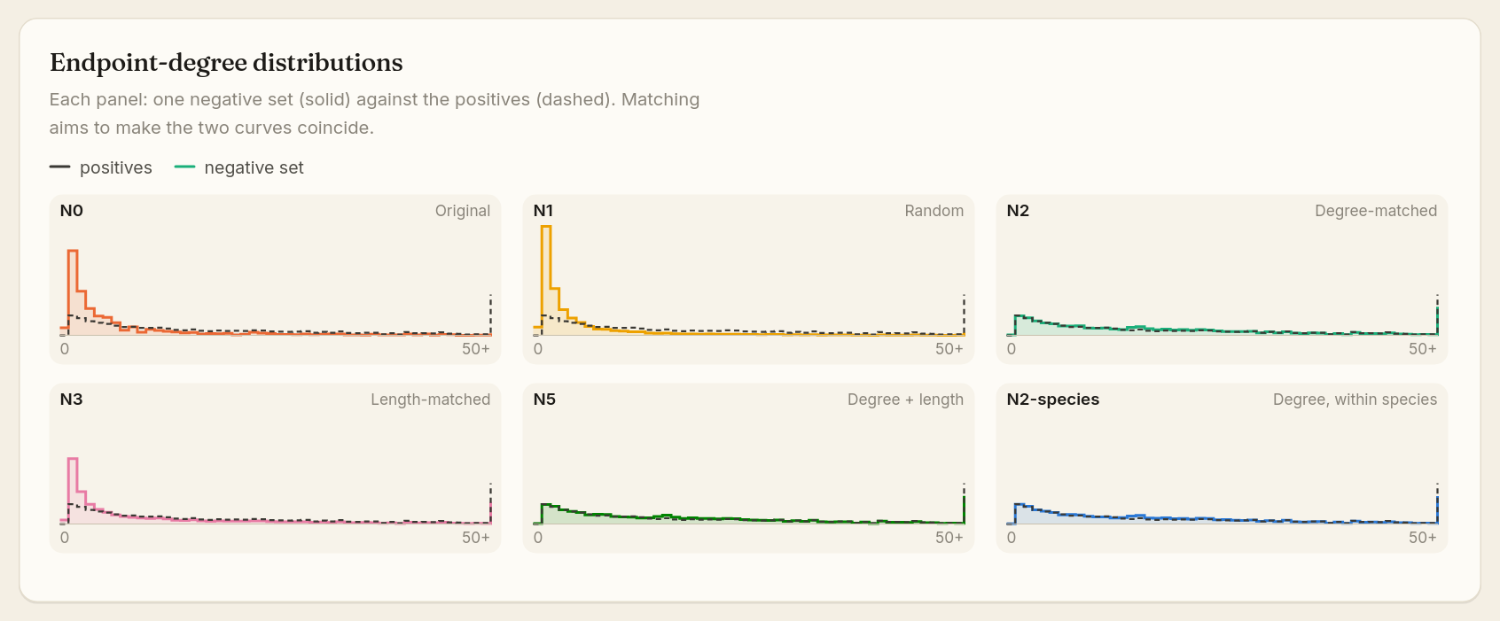
Figure 44. Small multiples: each panel compares one negative set (solid line) with the positives (dashed line).
Each small panel shows how degrees are spread out. When matching works, the solid and dashed lines lie on top of each other (N2, N5). When they differ a lot (N0, N1 rise sharply at low degree), negatives are made of less-connected proteins.

12. Chapter 3: Novelty, "Does it work on proteins it has never seen?"
A model is useful mainly for proteins whose partners are unknown. This chapter tests how performance changes as the test proteins become less familiar.
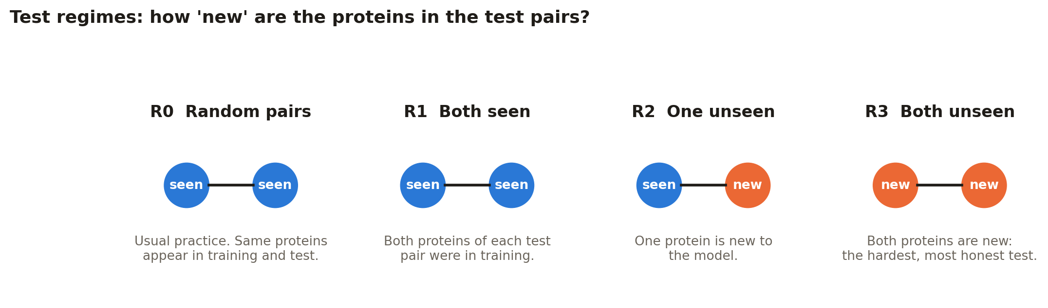
Figure 45. The test regimes. R1, R2 and R3 share exactly the same training set and differ only in their test pairs.

The novelty curve
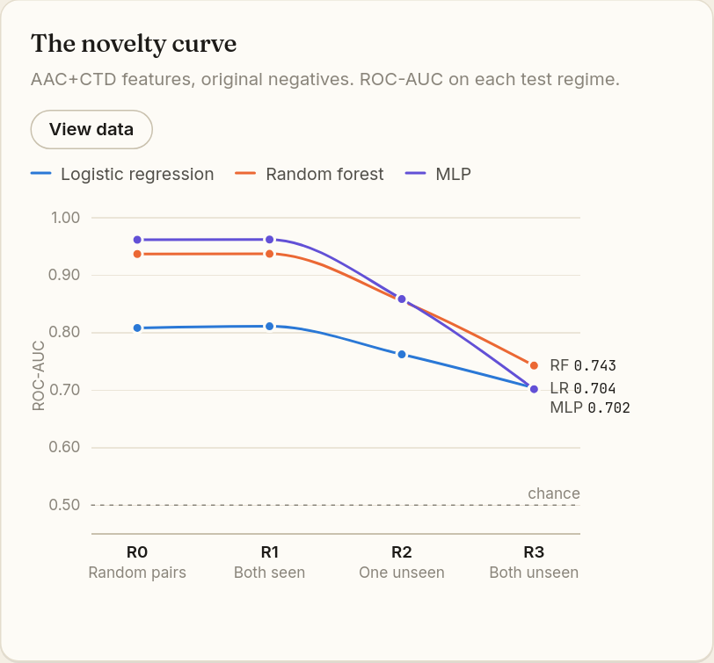
Figure 46. ROC-AUC of each model on each regime, using your original negatives.
How to read it: follow each line from left to right. A flat line means the model works just as well on new proteins. A line that falls means the model was relying on memorising familiar proteins. In the example the MLP falls from 0.96 (R1) to 0.70 (R3), a drop of 0.26, which earns a ✕ Concern. The Representation switch appears if you uploaded embeddings.
Drop from R1 to R3 | Badge
≤ 0.03 | ✓ Pass: performance holds on unseen proteins
0.03 – 0.10 | ! Caution
> 0.10 | ✕ Concern: random splits overstate performance on new proteins

ROC curves by regime
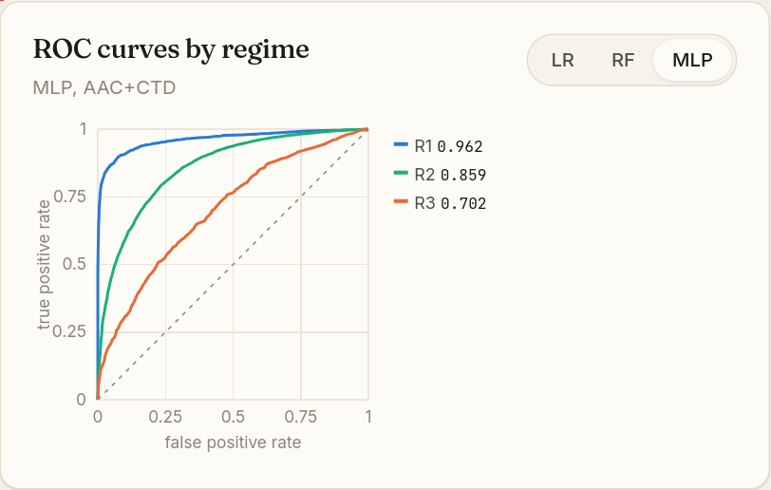
Figure 47. ROC curves for R1, R2, R3. Use the LR · RF · MLP switch to change the model.
Each curve plots the share of true interactions found (vertical axis) against the share of false alarms (horizontal axis) as the decision threshold changes. A curve hugging the top-left corner is excellent; the dotted diagonal is guessing. The number next to each regime in the legend is its ROC-AUC (the area under the curve).

Splits and leakage gates
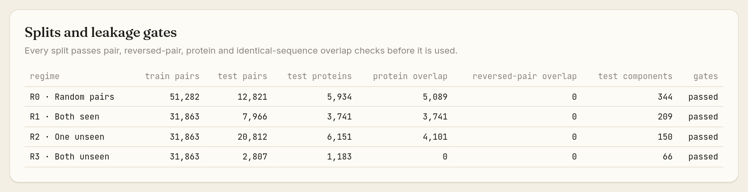
Figure 48. The split table. Every regime must show "passed" in the gates column.
Column | Meaning
train pairs / test pairs | Number of pairs used for training and for testing.
test proteins | Distinct proteins in the test set.
protein overlap | Test proteins also present in training: high for R0/R1, smaller for R2, and 0 for R3 by design.
reversed-pair overlap | B–A in test while A–B is in training: must always be 0.
test components | Independent groups of test pairs (see Chapter 6).
gates | "passed" means all leakage checks succeeded; "FAILED" would mean the split cannot be trusted.

13. Chapters 4–7: shortcuts, matched negatives, uncertainty and species

13.1 Chapter 4: Shortcuts, "Can a model cheat without sequence?"
Here the app deliberately trains "cheating" models that never see a protein sequence. One sees only four numbers about the degrees of the two proteins (sum, difference, minimum, maximum). The other sees the same four numbers for their lengths. They are trained on your original labels and tested against every negative set.
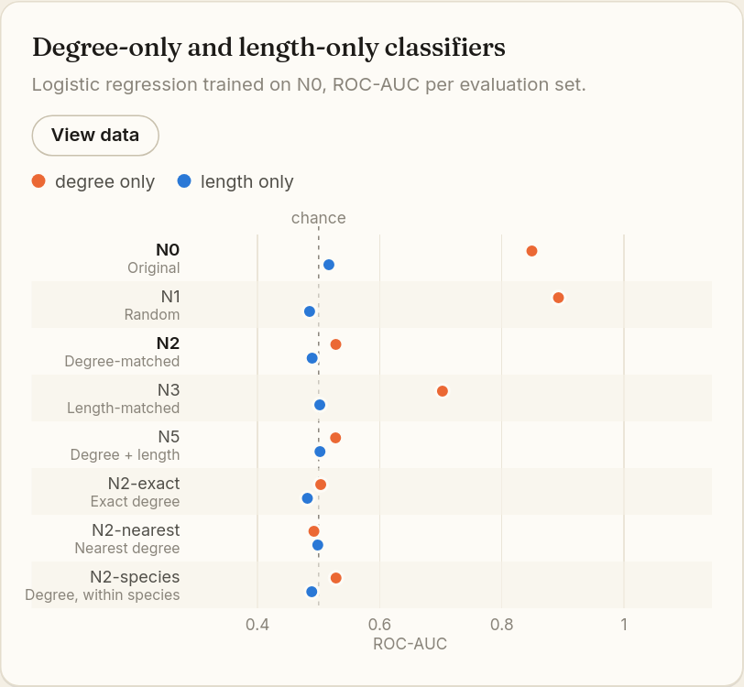
Figure 49. Degree-only (orange) and length-only (blue) classifiers on the multi-species example.
How to read it: dots near the dashed "chance" line (0.5) are good: that property cannot predict the labels. In the example the orange degree-only dot for N0 sits at 0.85, so degree alone reproduces most of the benchmark. On N2 it falls back to about 0.53, which confirms that degree matching removes the shortcut. Length-only dots stay near 0.5 (✓ Pass).
Degree-only ROC-AUC on N0 | Badge
≤ 0.65 | ✓ Pass
0.65 – 0.75 | ! Caution: report a degree-only baseline
> 0.75 | ✕ Concern: headline scores mix interaction signal with how well-studied proteins are

The length-only check is ✓ Pass up to 0.65 and ! Caution above it.
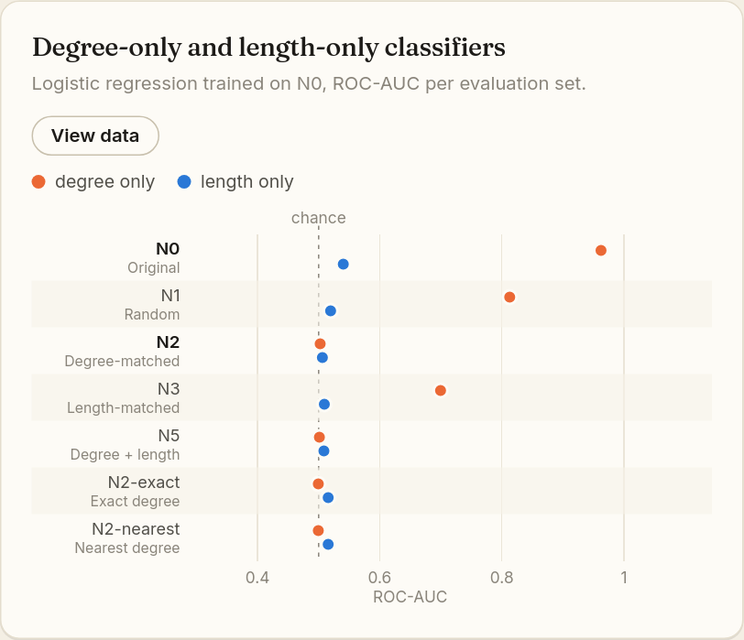
Figure 50. For comparison, the Guo yeast example: degree alone scores 0.96 on N0, yet about 0.50 on degree-matched N2.
WATCH OUT
Degree is computed from the same incomplete positive network that provides the labels. This is an audit feature. It is not a fair input for predicting partners of a protein nobody has studied yet.

13.2 Chapter 5: Matched negatives, "What survives when the shortcut is removed?"
The real sequence model (MLP) is now retrained and retested using each fair negative set for both training and testing, at R0 (random split) and R3 (both proteins unseen). This is the closest the app gets to asking whether the sequences themselves carry interaction signal.
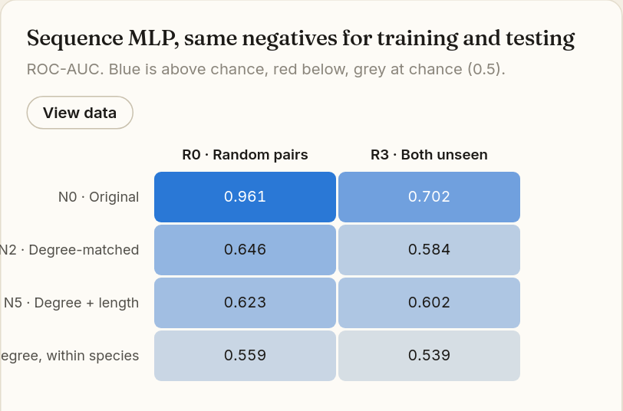
Figure 51. Heatmap of ROC-AUC. Darker blue = further above chance; red would be below chance; grey is at chance.
How to read it: look at the bottom-right area, the matched negative sets in the R3 column. That is the honest score. In the example N0 at R0 gives 0.96, but N2 at R3 gives only 0.58: modest signal (! Caution).
Best N2 ROC-AUC at R3 | Badge and meaning
< 0.45 | ✕ Concern: below chance, something is odd
0.45 – 0.55 | ✕ Concern: close to chance; little sequence signal survives
0.55 – 0.60, or not significant | ! Caution: modest or uncertain signal
≥ 0.60 and significant by both tests | ✓ Pass: sequence signal survives degree matching

Predicted scores at R3
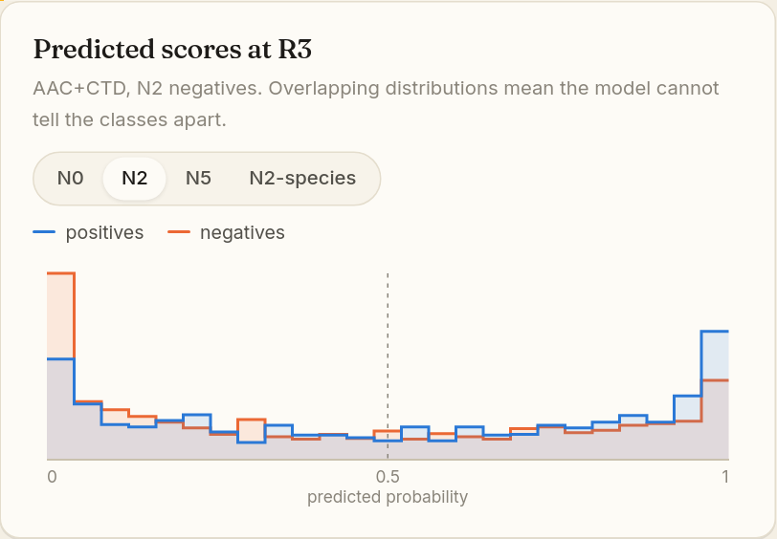
Figure 52. Histogram of the model's predicted probabilities for positives (blue) and negatives (orange) at R3. Switch the negative set with the pills.
If the two outlines are clearly separated (positives piled near 1, negatives near 0), the model can tell them apart. If they overlap almost everywhere, as here, it cannot.

13.3 Chapter 6: Uncertainty, "How sure can we be?"
Test pairs that share proteins are not independent; counting them separately would make results look more certain than they are. The app therefore resamples whole connected components of the R3 test network.
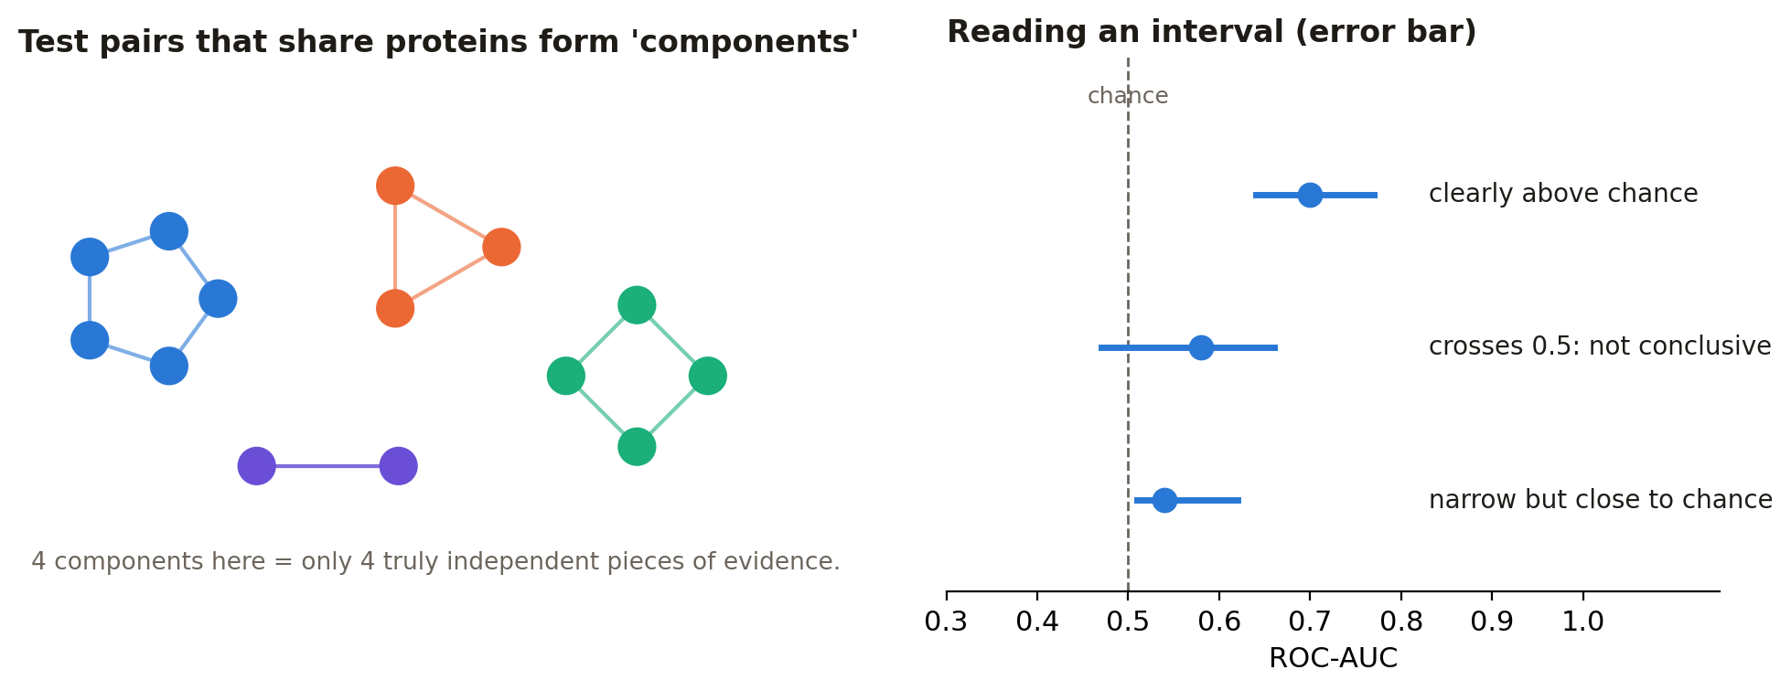
Figure 53. Left: why components, not pairs, are the units of evidence. Right: how to read an error bar.
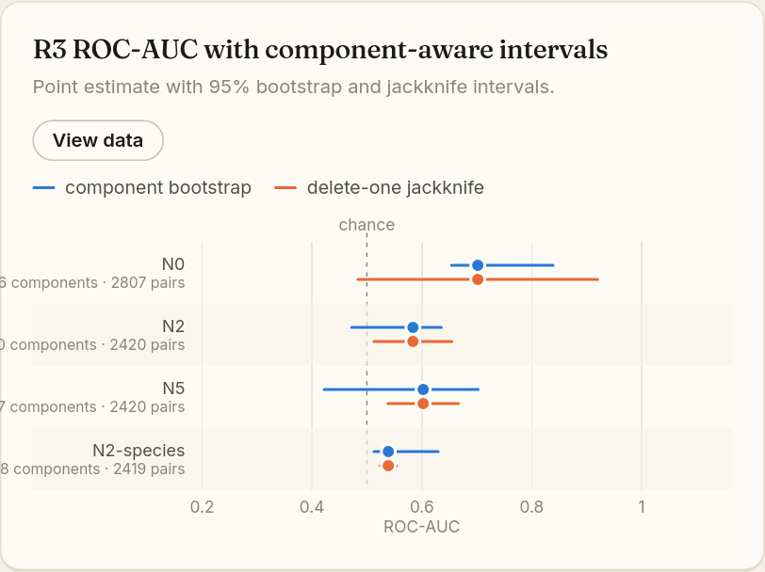
Figure 54. R3 ROC-AUC with 95% intervals: component bootstrap (blue) and delete-one jackknife (orange). The grey text under each label gives the number of components and pairs.
How to read it: the dot is the best estimate and the line is the range of plausible values. If the whole line is to the right of the dashed chance line, the signal is reliably above chance. If it crosses the line, the data cannot distinguish the model from guessing. P values (in View data, columns "boot p (BH)" and "jack p (BH)") test "ROC-AUC = 0.5" and are adjusted for multiple comparisons (Benjamini–Hochberg).
Fewest R3 components | Badge
≥ 30 | ✓ Pass: enough independent units
10 – 29 | ! Caution: wide intervals; small differences between models are not meaningful
< 10 | ✕ Concern: very little independent evidence

IN PLAIN WORDS
"Not significant" does not mean "proven to be at chance". It means the data cannot tell, often because there are too few independent components.

13.4 Chapter 7: Species, "Is the model recognising organisms?"
This chapter appears only for multi-species data with species diagnostics switched on.
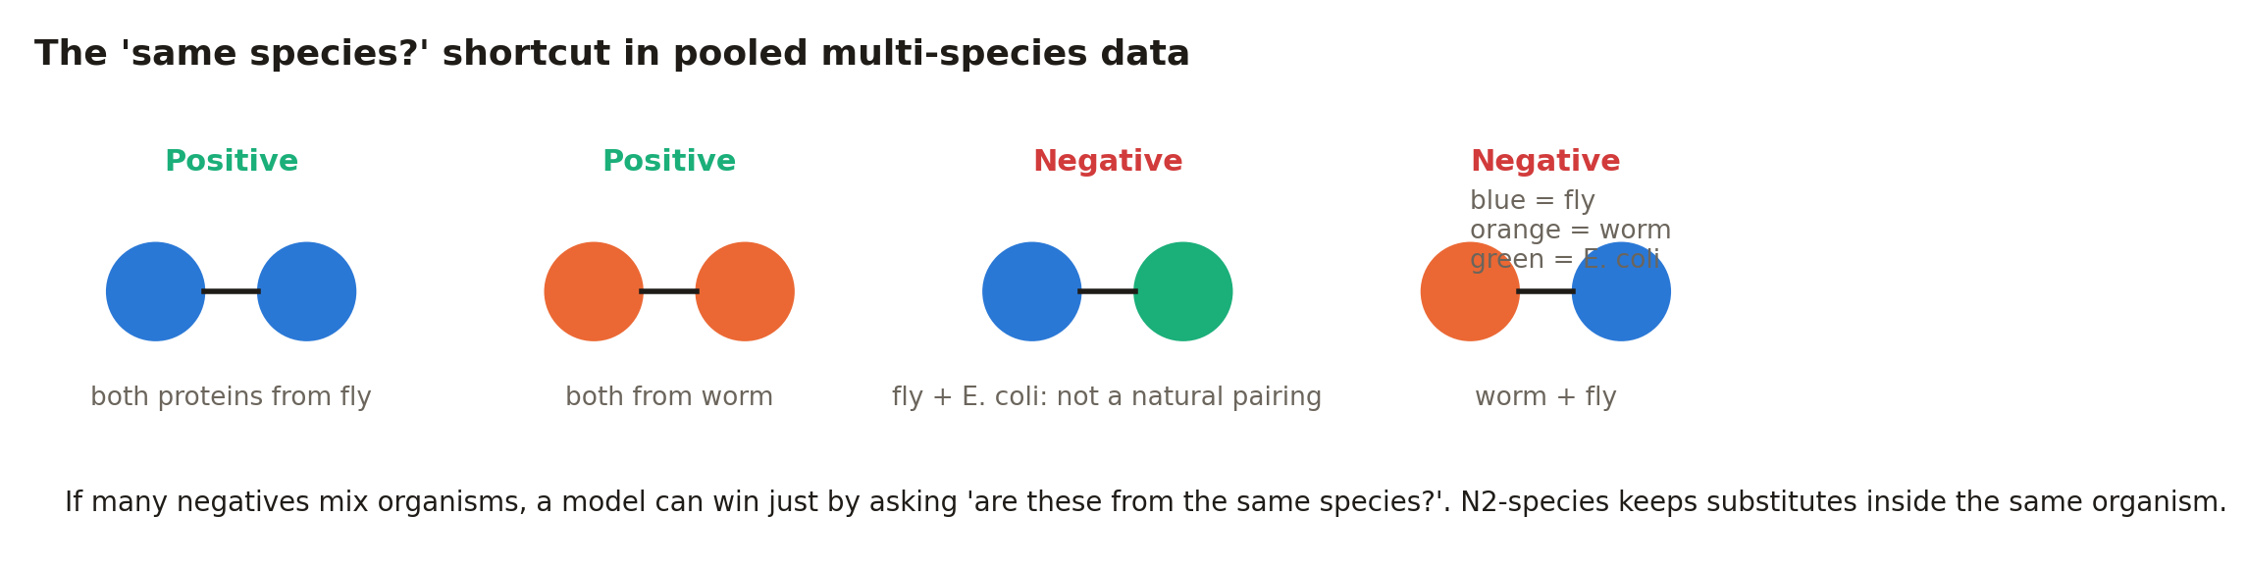
Figure 55. The taxonomic shortcut.
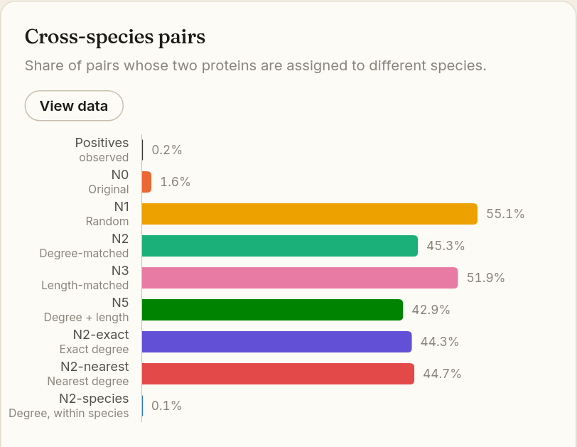
Figure 56. Share of pairs whose two proteins come from different species, per set.
Real positives almost never mix organisms (0.2% here). Random and degree-matched negatives often do (N1 55%, N2 45%). N2-species brings this back to 0.1%. Badge: ! Caution when more than 10% of N2 negatives cross species while positives stay under 5%.
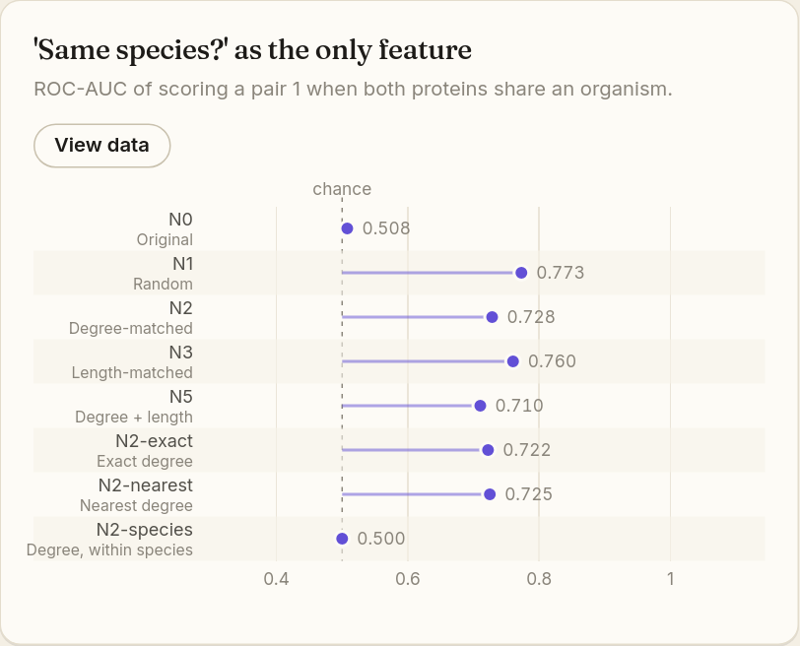
Figure 57. "Same species?" used as the only feature.
This "model" simply says "interacts" whenever both proteins come from the same organism. A score near 0.5 is good. In the example it reaches 0.73 on N2 (✕ Concern above 0.70; ! Caution above 0.60), but exactly 0.50 on N2-species, which shows that species-matched negatives remove the shortcut.
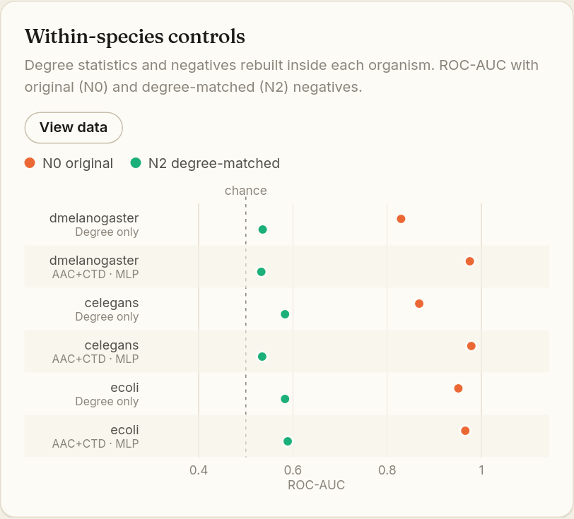
Figure 58. Within-species controls: each organism analysed separately with original (orange) and degree-matched (green) negatives.
For each organism there are two rows: the degree-only model and the sequence MLP. Orange (N0) dots far to the right with green (N2) dots near chance show that, inside each species, the shortcut explains most of the original score. The badge is "i Context" because these within-species splits do not control protein reuse.
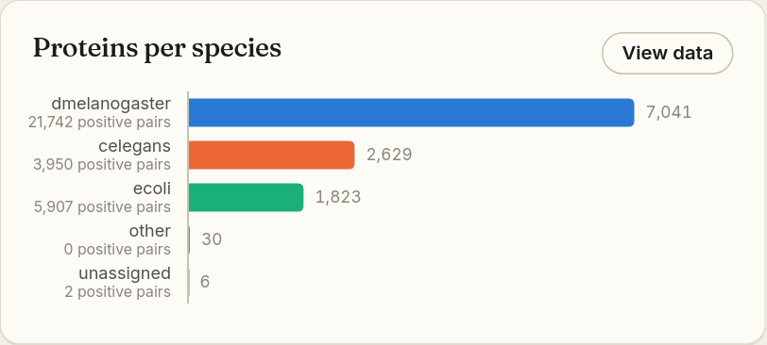
Figure 59. Proteins per species, with the number of positive pairs under each name. Species with too little data are listed as "Not analysed within species".

14. Chapter 8: "Use the results to build a better model"
The last chapter turns the findings into actions and files.

14.1 Recommendation cards
Each card gives one concrete recommendation and a download button for the file you need. Which cards appear depends on your diagnostics.
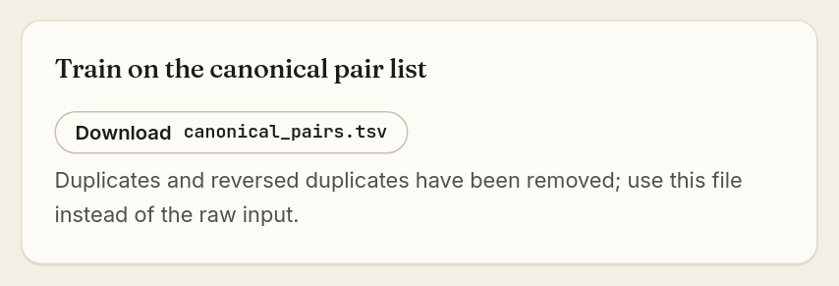
Figure 60. A recommendation card with its download button.
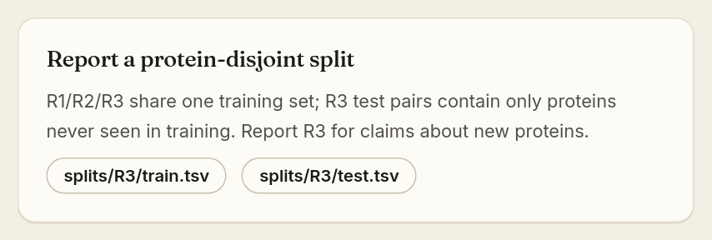
Figure 61. For splits, two buttons download the training and test files.
Card | Appears when | File
Train on the canonical pair list | Duplicates were removed | canonical_pairs.tsv
Use degree-matched negatives | Negative bias or degree shortcut is Caution/Concern | negatives/N2.tsv
Report a protein-disjoint split | Novelty drop is Caution/Concern | splits/R3/train.tsv, splits/R3/test.tsv
Report component-aware uncertainty | Few independent components | tables/component_aware_uncertainty.csv
Match negatives within species | Taxonomic or cross-species issue | negatives/N2-species.tsv
Report both controls | Always | results.json

14.2 Downloads, methods paragraph and fingerprint
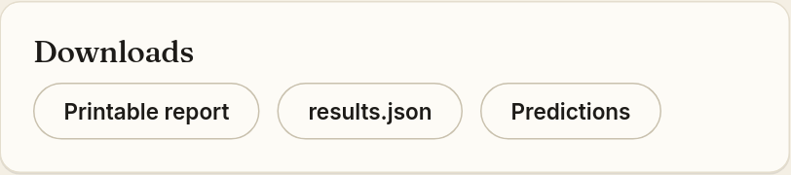
Figure 62. The Downloads card. "Full bundle (.zip)" appears for your own jobs (not for examples).
Button | What you get
Full bundle (.zip) | Everything in one archive: canonical pairs, all negative sets, all splits (R0–R3 train/test), all tables, predictions, the report and results.json.
Printable report | A self-contained HTML page with the verdict and every diagnostic; opens in a new tab. Use your browser's Print ▸ Save as PDF to make a PDF.
results.json | Every number in machine-readable form, for scripts or supplementary material.
Predictions | sample_level_predictions.csv.gz: the model's score for every test pair.

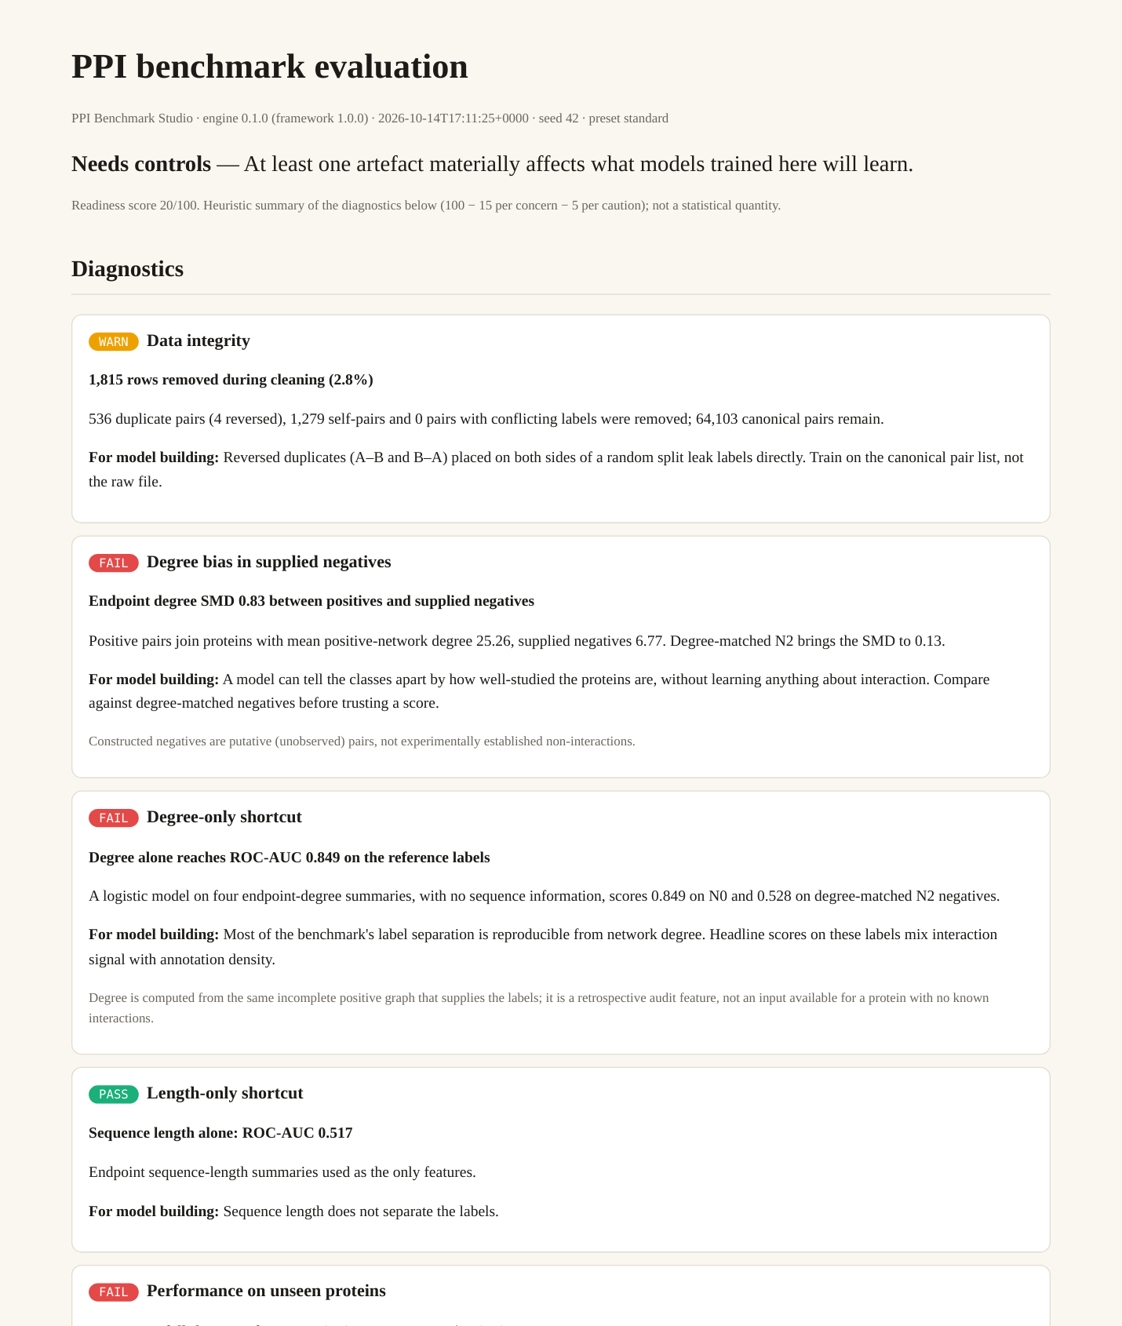
Figure 63. The printable report (opened from "Printable report").
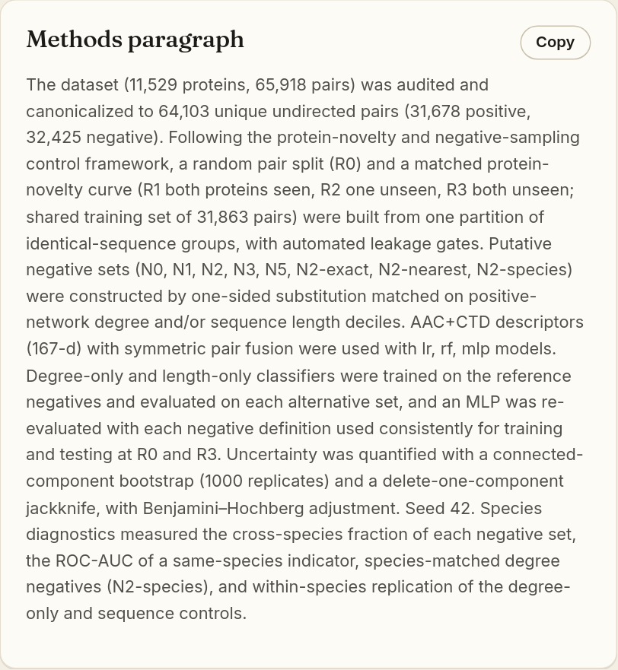
Figure 64. The Methods paragraph, filled in with your numbers. "Copy" puts it on the clipboard.
The Methods paragraph describes what was done, using your actual counts, settings and seed, in the style of a scientific paper. Click Copy and paste it into your report or manuscript; check and edit it before publishing.
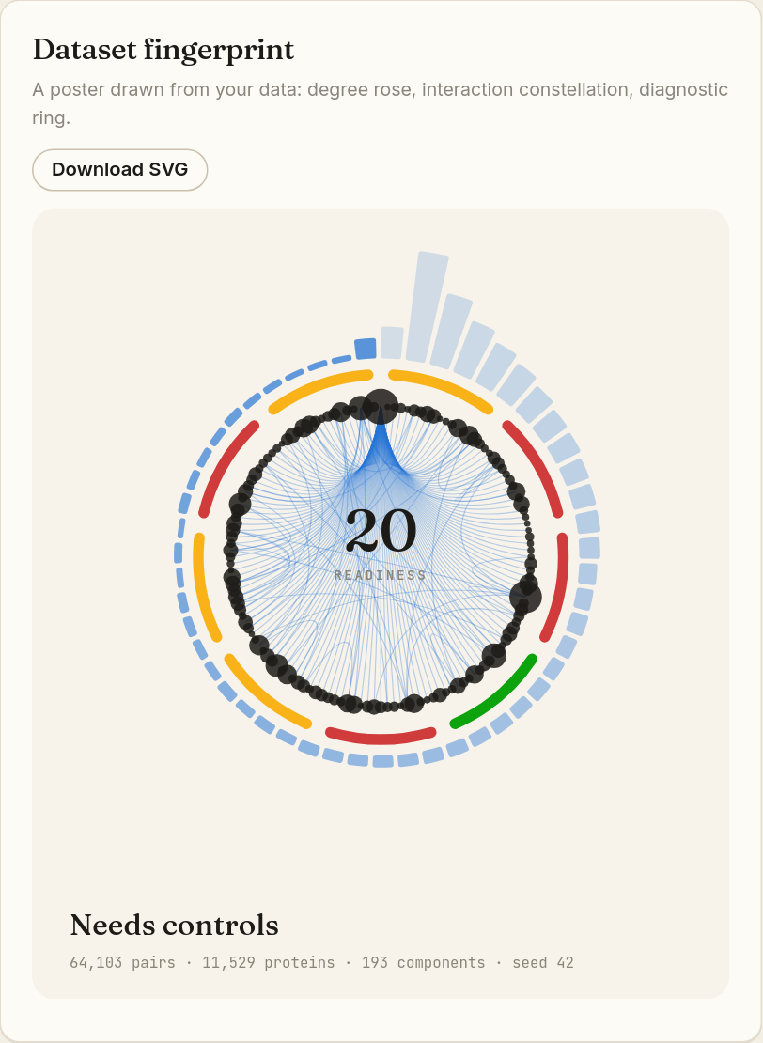
Figure 65. The Dataset fingerprint poster.
The Dataset fingerprint is a decorative poster drawn from your data. The outer petals show the degree distribution, the inner circle of dots and chords is part of your interaction network, the coloured ring segments are the diagnostics (green/amber/red), and the centre shows the readiness score. Download SVG saves it as a scalable image for slides or posters. Do not read values from it: they are in the chapters above.

14.3 What is inside the bundle
Path in the .zip | Contents and typical use
canonical_pairs.tsv | Cleaned, de-duplicated pairs. Use instead of your raw pair file.
negatives/N0.tsv … N5.tsv (and N2-exact, N2-nearest, N2-species when built) | Each negative set as a pair list. Train with a matched set (usually N2 or N5).
splits/R0 … R3/train.tsv, test.tsv | Leakage-checked train/test splits. R3 is the protein-disjoint split for claims about new proteins.
tables/negative_set_balance.csv | SMD, KS and means for each negative set (Chapter 2).
tables/novelty_curve_metrics.csv | ROC-AUC and other metrics per model and regime (Chapter 3).
tables/split_summary.csv | The splits-and-gates table.
tables/topology_controls.csv | Degree-only and length-only results (Chapter 4).
tables/consistent_negative_revalidation.csv | Matched-negative heatmap values (Chapter 5).
tables/component_aware_uncertainty.csv | Intervals and p values (Chapter 6).
tables/protein_statistics.csv | Per-protein degree, length and other statistics.
predictions/sample_level_predictions.csv.gz | Per-pair predicted scores.
report.html, results.json | Printable report and the full machine-readable results.

15. Interpretation guide: all diagnostics on one page
The table below lists every diagnostic, what it measures and the exact rule that sets its badge. The rules are fixed: the same results always give the same badges.
Diagnostic | What is measured | ✓ Pass | ! Caution | ✕ Concern
Data integrity | Rows removed during cleaning | Nothing removed, or ≤ 1% with no conflicts | > 1% removed, or any conflicting labels | —
Degree bias in supplied negatives | |SMD| of degree, positives vs N0 | ≤ 0.25 | 0.25–0.8 | > 0.8
Degree-only shortcut | Degree-only ROC-AUC on N0 | ≤ 0.65 | 0.65–0.75 | > 0.75
Length-only shortcut | Length-only ROC-AUC on N0 | ≤ 0.65 | > 0.65 | —
Performance on unseen proteins | ROC-AUC drop R1 → R3 | ≤ 0.03 | 0.03–0.10 | > 0.10
Signal after degree matching | Best N2 ROC-AUC at R3 + significance | ≥ 0.60 and significant | 0.55–0.60 or not significant | < 0.55 (near or below chance)
Independent test units | Fewest R3 components | ≥ 30 | 10–29 | < 10
Taxonomic shortcut | "Same species?" ROC-AUC on N2 | ≤ 0.60 | 0.60–0.70 | > 0.70
Cross-species negatives | Share of N2 crossing species | otherwise | > 10% (positives < 5%) | —
Within-species signal | MLP N2 ROC-AUC per species | i Context (not scored)

When you supplied no negatives, "Degree bias in supplied negatives" becomes i Context and random pairs (N1) serve as the reference set.

15.1 The three examples side by side
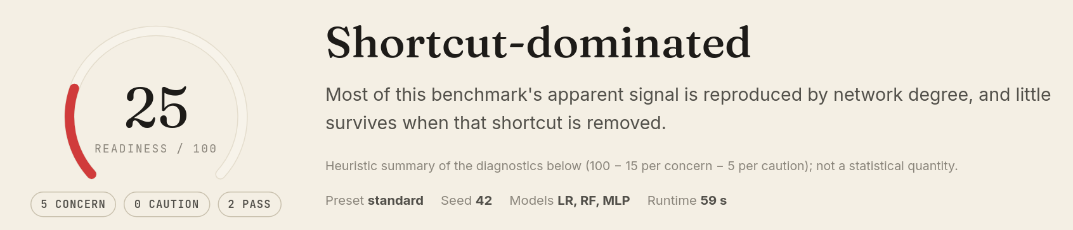
Figure 66. Guo yeast: "Shortcut-dominated", score 25.
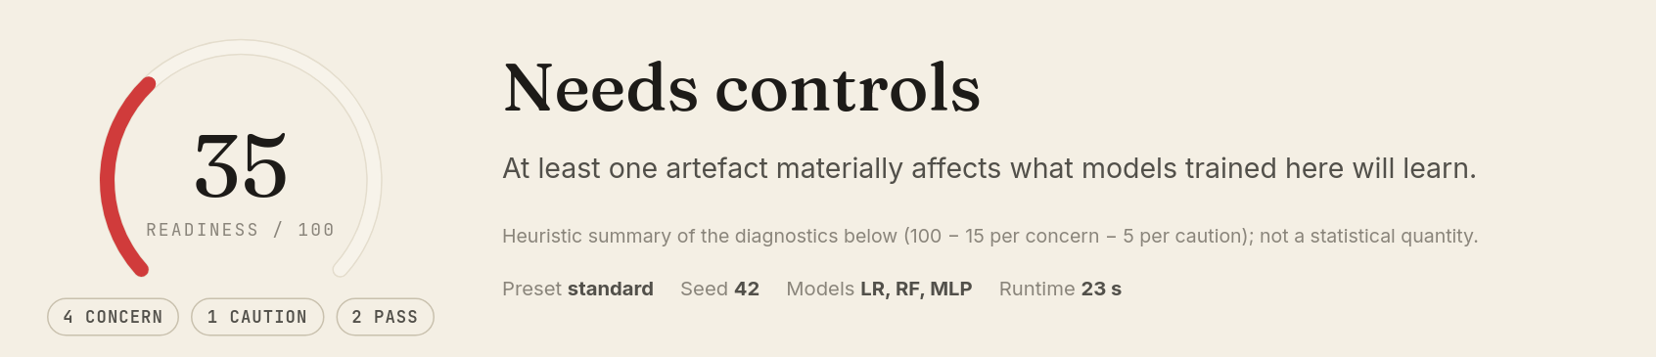
Figure 67. Synthetic control: "Needs controls", score 35.
Question | Multi-species | Guo yeast | Synthetic
Do supplied negatives join less-studied proteins? (N0 SMD) | Yes, 0.83 (Concern) | Yes, 1.16 (Concern) | Yes, 0.99 (Concern)
Can degree alone predict the labels? (N0) | Yes, 0.85 | Yes, 0.96 | Yes, 0.98
…and with degree-matched negatives? (N2) | 0.53 | 0.50 | 0.51
Does the sequence model hold on unseen proteins? (R1 → R3 drop) | Drops 0.26 | Drops 0.11 | Drops 0.19
Sequence signal after matching (N2, R3) | Modest, 0.58 | Near chance, 0.52 | Modest, 0.71
Species shortcut | Yes, 0.73 | n/a | n/a
Independent R3 components | 17–66 (Caution) | 5–19 (Concern) | 2–7 (Concern)
Verdict (score) | Needs controls (20) | Shortcut-dominated (25) | Needs controls (35)

Lesson: all three datasets have a strong degree shortcut, but they differ in what remains once it is removed. The Guo benchmark keeps essentially nothing; the synthetic and multi-species data keep some genuine signal. That is why you need to evaluate your own dataset rather than rely on a benchmark's reputation.

15.2 What should I do next? A decision guide
If you see… | It means… | Do this
Concern: degree bias / degree-only shortcut | Your labels can be predicted from protein popularity. | Train and test with negatives/N2.tsv (or N5). Always report the degree-only baseline next to your model's score.
Concern: performance on unseen proteins | Random splits overstate performance on new proteins. | Report results on splits/R3. Make claims about "new proteins" only from R3.
Concern/Caution: signal after degree matching | Little sequence signal survives. | Treat headline scores with caution; consider a better representation (upload embeddings) or a different dataset.
Caution/Concern: independent test units | Too few independent components; intervals are wide. | Quote component-aware intervals; add an independent test dataset if you can.
Concern: taxonomic shortcut | The model can win by recognising organisms. | Use negatives/N2-species.tsv and report within-species results.
Caution: data integrity | Your raw file contains duplicates or conflicting labels. | Use canonical_pairs.tsv; investigate conflicting labels at the source.
Robust (all Pass) | No diagnostic crossed its threshold. | Proceed, but still report R3 and matched-negative results for transparency.

16. Troubleshooting and frequently asked questions
Problem | Likely cause and fix
"Upload & preview" stays faded | Both required files (Proteins and Pairs) must be chosen.
Error: "rows have a label that is not 0/1" | The label column contains other text (for example "maybe"). Use 1/0, true/false, yes/no or positive/negative.
Error about IDs not found | IDs in the pair file do not match the protein file exactly. Check capitals, version suffixes (P12345 vs P12345.2) and spaces.
Columns detected in the wrong place | Change the drop-down menus in Step 2, then click Validate again.
"No header" shown but my file has one | The header may look like data (for example IDs as column names). Make sure the first row contains column names such as protein_a, protein_b, label.
File too large / too many pairs | The server limits are shown on the Format page. Use the local Docker version for very large datasets.
"Waiting for a free worker" | Other analyses are running. Leave the page open or bookmark it; the job starts automatically.
"Evaluation not found" | The result has passed the retention period (30 days on this server) or the link is wrong. Run the analysis again.
The page cannot be reached at localhost:8000 | The server is not running, or it runs on a different port. Start it with docker compose up (Section 1.3).
No Species chapter | No species information was supplied, only one species was found, or species diagnostics were switched Off in Step 3.
A chart is hard to read | Click View data to see the numbers, or switch between light and dark mode.

Frequently asked questions
Is my data private? There are no user accounts. Each dataset and result has a long, hard-to-guess address, but anyone who has the link can open the results. Share links only with people who should see them. Files are deleted automatically after the retention period.
Will I get the same answer if I run it again? Yes, if you use the same files, preset and seed.
Does a low score mean my model is useless? No. It means this dataset, as constructed, cannot show that a model has learned biology rather than a shortcut. Use the cleaned files to build a fairer test.
Can I use protein language-model embeddings? Yes. Compute them yourself (for example with ESM-2) and upload them as the optional Embeddings file. Every chapter will then show both representations.
Can I run it without the web page? Yes. A command-line tool is included (Appendix A).

Appendix A. Command-line use (optional)
For people comfortable with a terminal, the same analysis runs without the web interface. From the project folder:
Command | What it does
.venv/bin/ppi-studio validate --proteins P.tsv --pairs X.tsv [--species S.tsv] | Checks the files and prints the issues, like the Validate step.
.venv/bin/ppi-studio run --proteins P.tsv --pairs X.tsv --species S.tsv --out out/ --preset standard | Runs the full evaluation and writes the same files as the bundle into out/.
.venv/bin/ppi-studio demo --out out/demo | Runs the analysis on built-in demonstration data.

Appendix B. Quick reference card
I want to… | Go to | Click
Learn what the tool checks | Framework | Read the page; "See worked examples"
Get a correctly formatted file | Format | Template · pairs.tsv / proteins.tsv
Test a few lines of my file | Format ▸ Check a snippet | Choose file type ▸ paste ▸ Check format
See finished results without uploading | Examples | Open the results →
Analyse my data | Evaluate | Choose files ▸ Upload & preview ▸ Validate ▸ Continue ▸ Run evaluation
Practise quickly | Evaluate | Use synthetic data
See the numbers behind a chart | Any chart | View data
Jump to a chapter | Results | Chapter bar at the top
Understand a finding | Results ▸ Verdict | ▸ What was measured / See the evidence →
Get cleaned training files | Results ▸ Use the results | Download buttons or Full bundle (.zip)
Write my methods section | Results ▸ Use the results | Methods paragraph ▸ Copy
Make a PDF | Results ▸ Downloads | Printable report ▸ browser Print ▸ Save as PDF
Switch to dark mode | Any page | Moon/sun button, top right

